PUM 51 – Fluid eProcurement Requester Guide

Getting Started
To access Fluid eProcurement, select the LSU Health Financials Homepage and then the eProcurement Tile
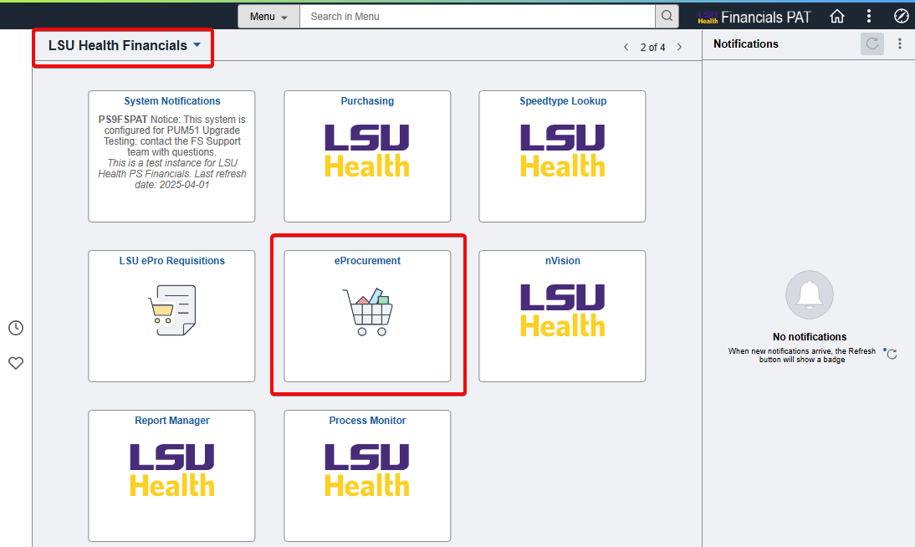

Within the eProcurement tile, two tiles will be available. The Create Requisition tile is for creating new requisitions. The My Requisition tile is for performing new tasks on existing requisitions, such as edit, approve, cancel, and print.
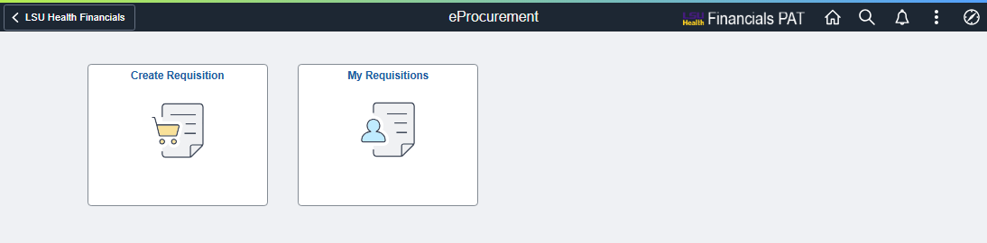

Create Requisition

Requisition Defaults
To create a requisition, select the Create Requisition tile. This will open the Requisition Defaults page, where initial values for the requisition can be set.
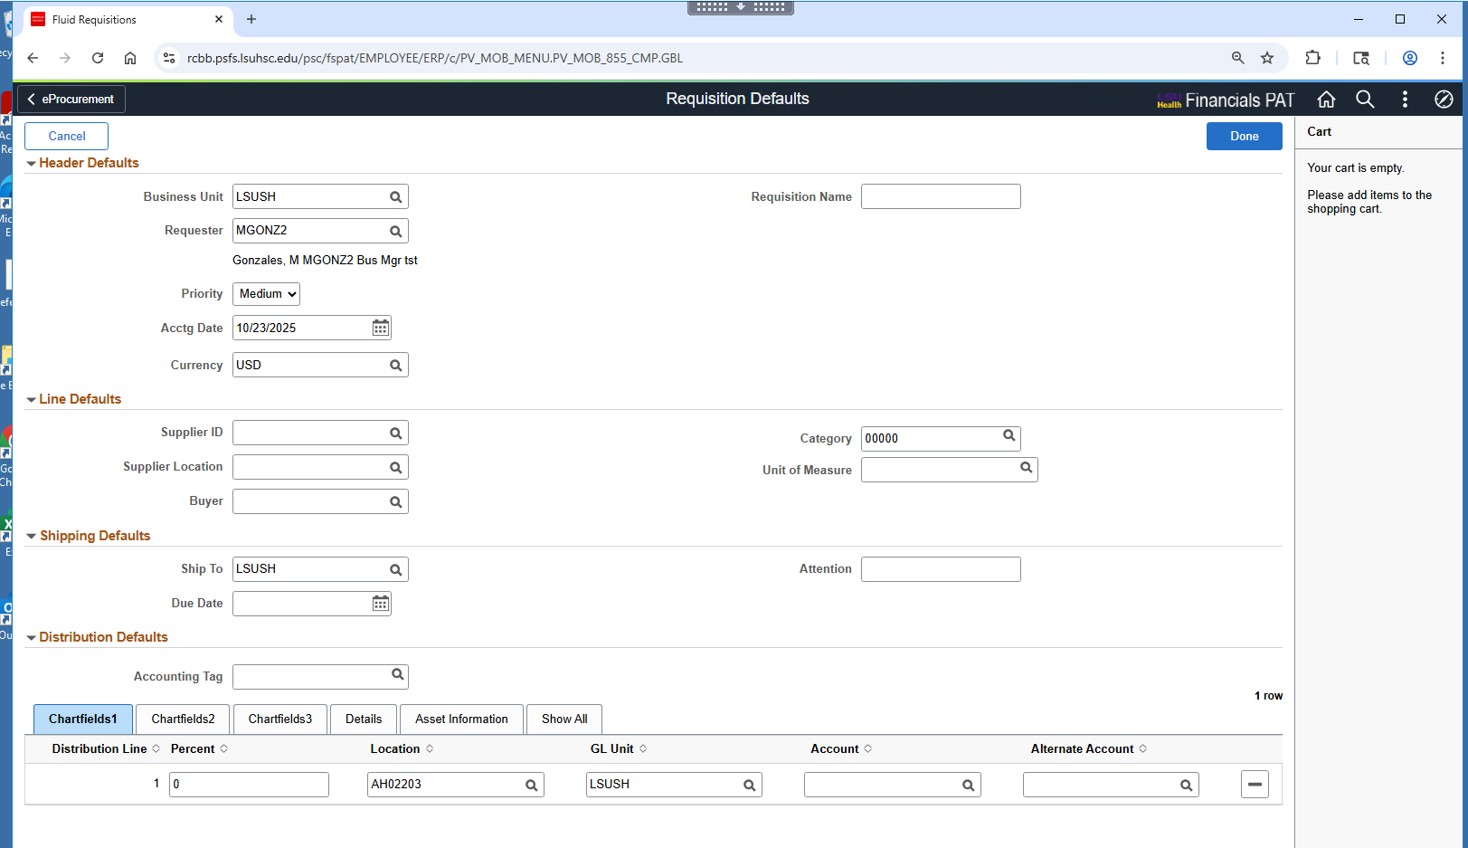
This page is entirely optional – all, some, or no values can be entered here. Whichever values that are entered will be present in the requisition going forward. To expand the various sections, click on the arrow next to each section header
Sections collapsed:
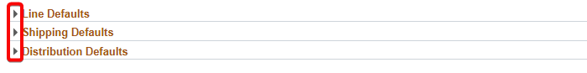
Sections expanded:
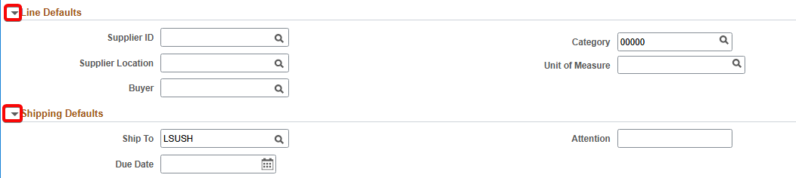
Once done with this page, click on the Done button at the top-right of the page.

eProcurement Main Page
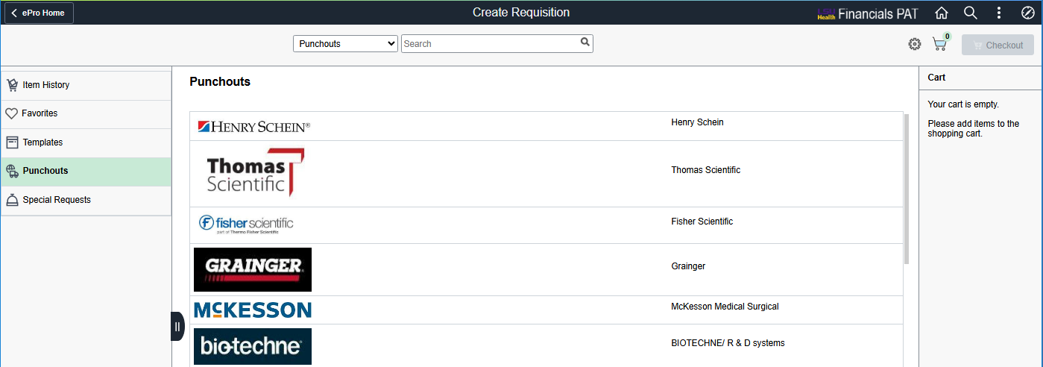
The eProcurement Main page for creating requisitions has 3 sections
- Navigation frame for Item History, Favorites, Templates, Punchouts, and Special Requests
- Main frame where that will display the page chosen from the Navigation frame. By default, the Punchouts page is displayed
- Gear Icon and Cart frame showing what is currently in the requester’s cart

Navigation frame
- The Item History page allows the requester to re-order items that were recently requested
- The Favorites page allows requesters to order items that were saved as Favorites, which can be special request items and punchout items
- Templates page allows the user to submit full requisitions that were saved as templates
- Punchouts page shows a list of punchout suppliers that the requester can select to view and order from the supplier’s external ordering catalog
- Special Requests are for requesting all other items that aren’t available from or chosen not to order from punchout suppliers

Gear Icon and Cart
- Near the top-right of the page is a Gear Icon. Selecting it will display a sub-menu for Requisition Defaults and Settings
- Items currently in cart can be viewed in the Cart Frame
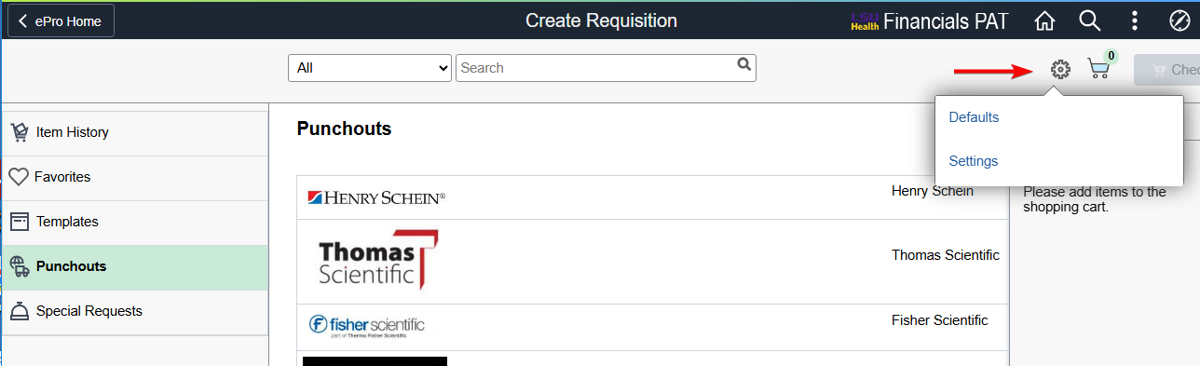

Requisition Defaults page via Gear Icon
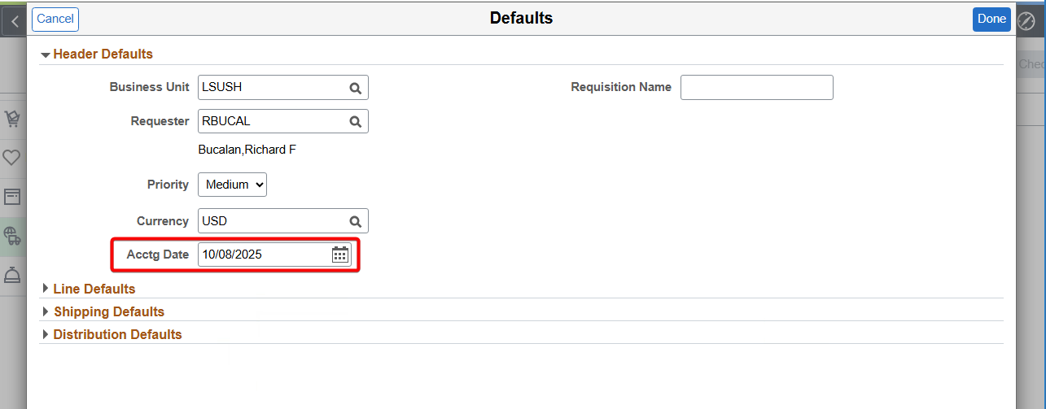
The Requisition Defaults page can be accessed via the Gear Icon, and this page is nearly identical to the version used when first selecting the Create Requisition tile.
Accounting Date can be set to a future date using the Requisition Defaults page or here via Gear Icon. This is required for creating a next-fiscal-year requisition. Updating the Accounting Date will also update the Budget Date for each requisition line (i.e. items in cart).
However, any other changes made in this page are not retroactive and will not affect items that were in cart before the changes. For example, if an item was already in cart and a different chartfield, such as Account, was used, the Account for the item in cart will not update to the new one, but any additional items added to cart will have the new Account number.
To reiterate, the purpose of Requisition Defaults page is to set initial values for requisition items. If the desired action is to update values for all existing items in cart, the Mass Change function explained later in this guide would have to be utilized. This is a critical change from prior versions of requisitioning.

Punchout Requisitions
To access punchout requisitions, select Punchouts from the Navigation frame
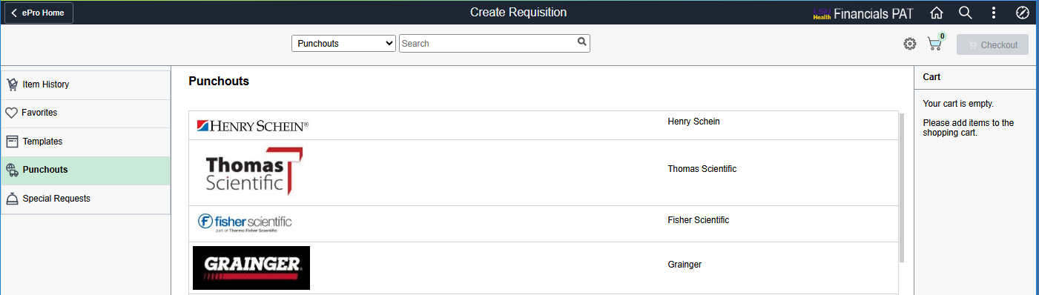
Selecting a supplier will bring up their external website for ordering directly from their catalog. In this example, Staples was chosen and pens were ordered
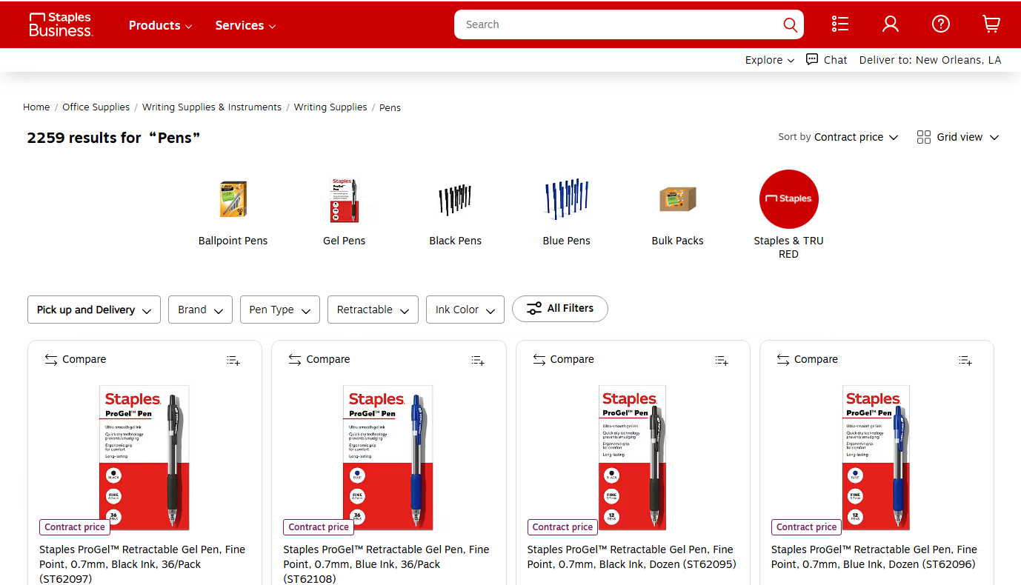
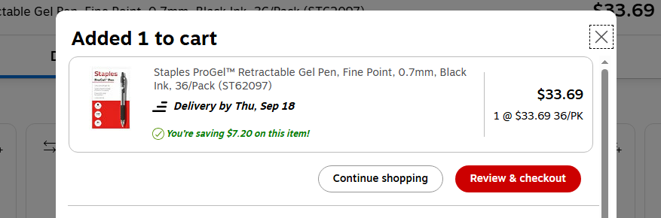

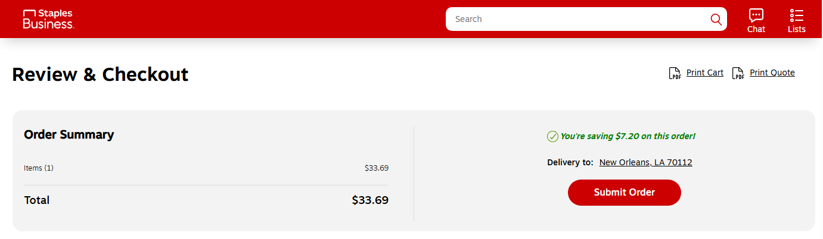
Once all items have been added to cart, check out and then submit order to return to PeopleSoft.
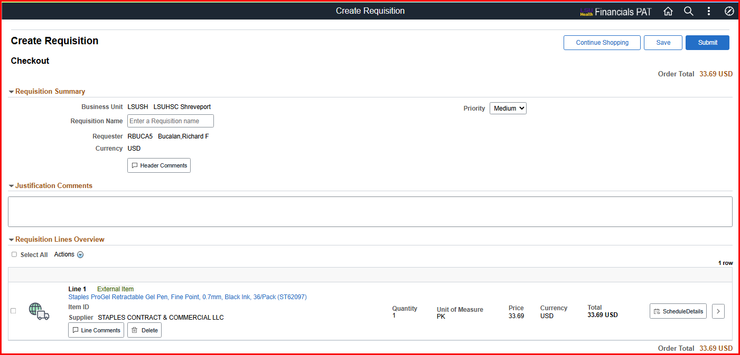
Returning to PeopleSoft brings up the eProcurement Checkout page, where comments, attachments, and chartfield information can be entered before submitting the requisition for approval.
Punchout items are marked as “External Item” on their requisition line.

Special Requests
To create a Special Request requisition, select Special Request from the Navigation frame
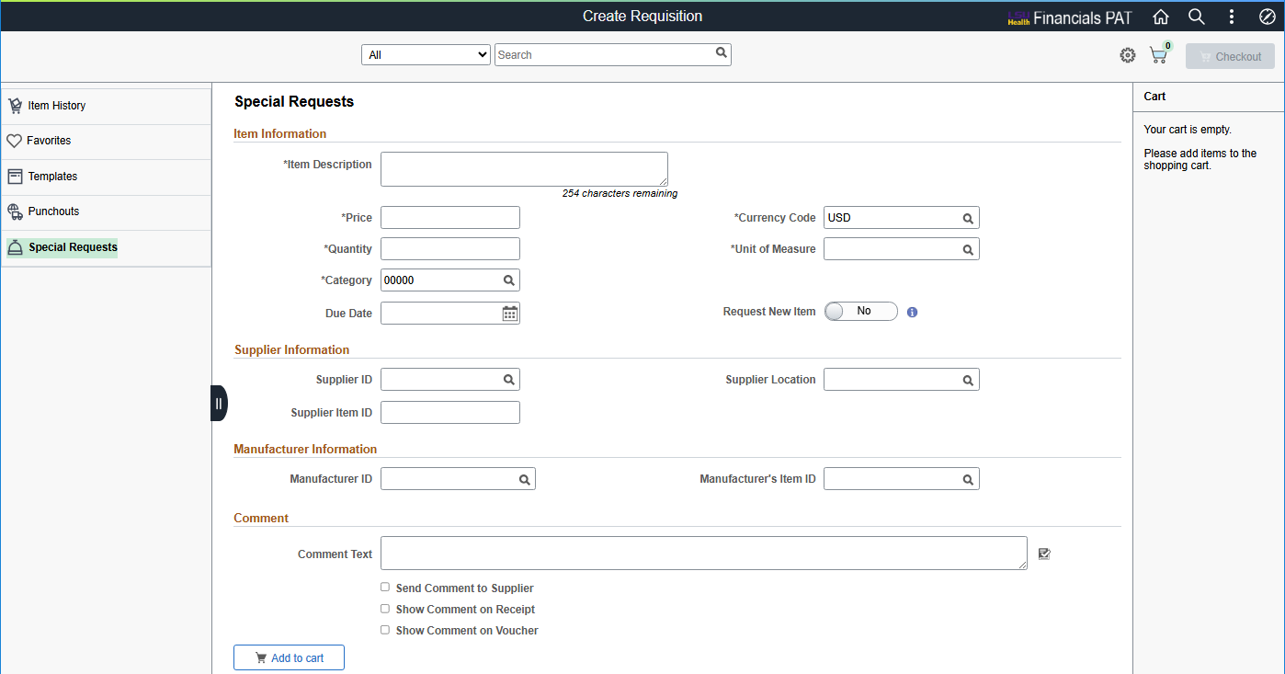
Enter a description for the special request item, the price, the quantity, and the unit of measure. Enter the Supplier if known.
A comment for this line item can be entered in the Comment section.
For this example, the following was entered:
- Item Description: SPECIAL REQUEST ITEM
- Price: 5.00
- Quantity: 1
- Unit of Measure: EA
- Supplier: 0000041388 ODP Business Solutions
- Comment: SPECIAL REQUEST COMMENT
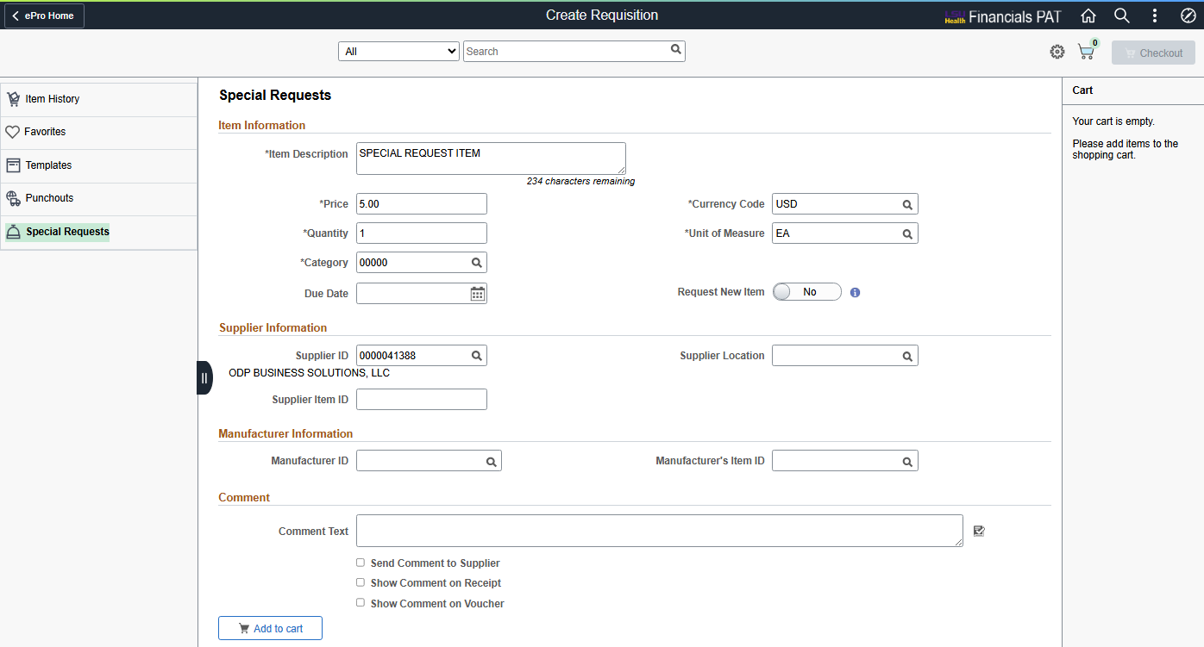
Select the Add to Cart button to add this special request item to the cart
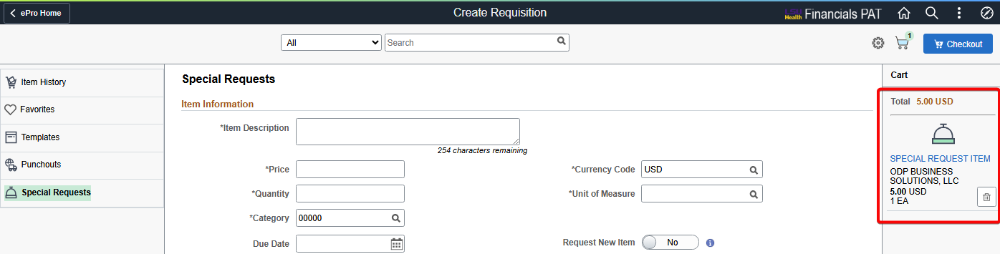
Select the Checkout button at the top-right to go to the Checkout page.

Checkout
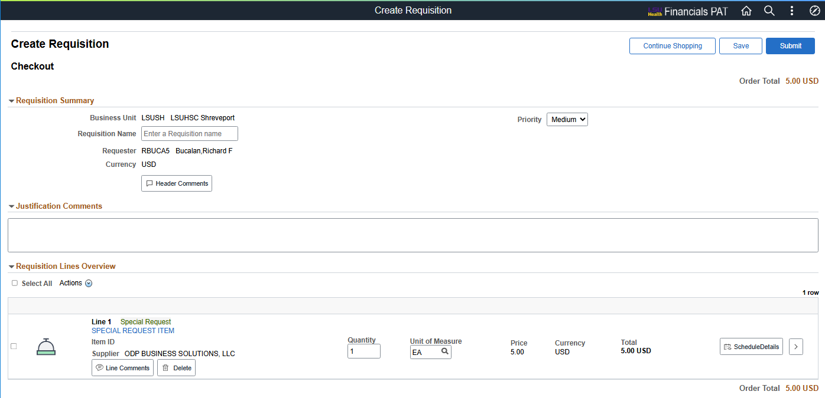
Use the Checkout page to review the contents of the requisition, to make final adjustments to quantity & UOM, add last-minute items to the requisition, to edit the chartfield distribution, and to submit the requisition for approval.

Requisition Header
A name for the requisition can be entered in the header. If left blank, the requisition’s ID number will automatically populate.
A level of priority can be assigned to the requisition. By default, all requisitions are medium priority.

Comments and Attachments
Comments can be entered at the header, line, and justification levels.
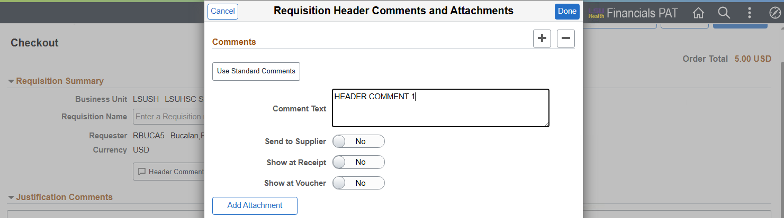
To add an attachment, select the Add Attachment button.
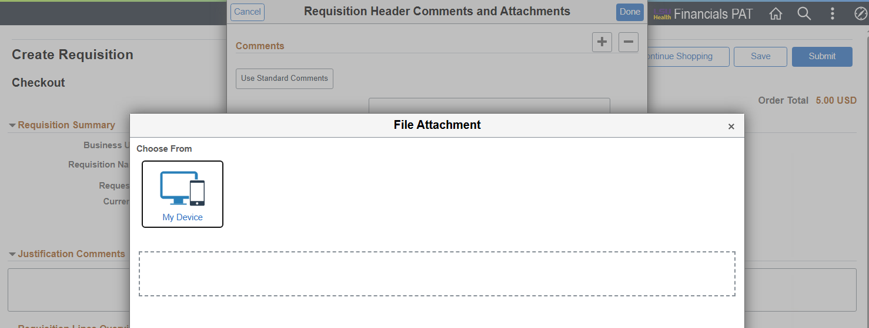

The attachment can be added by selecting the My Device button and then searching for the attachment on your device, or the attachment can be dragged-and-dropped from a separate window into the blank space below the button. Up to 10 attachments can be added, but no more than 3 can be added at one time.
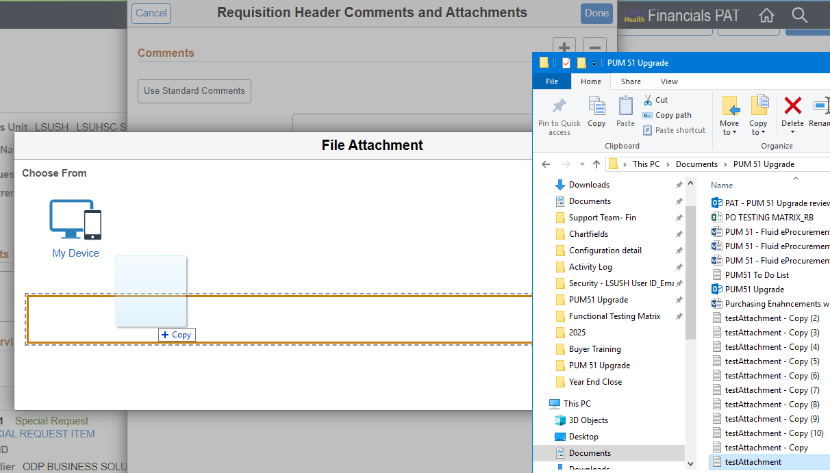
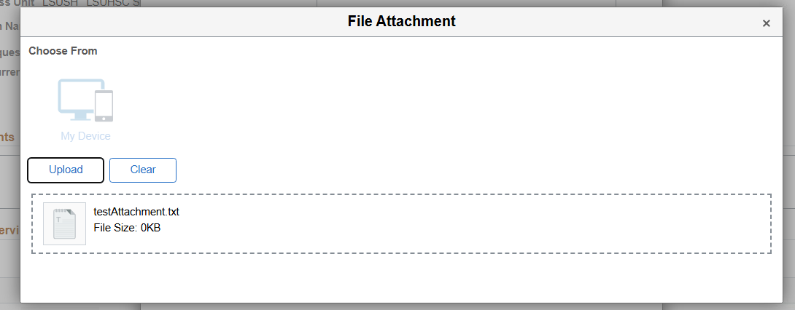

Under the Header, Justification Comments can be added. Here is where justification for the requisition is entered and these comments appear on the Requisition Approvals page for approver review.

Requisition Lines Section
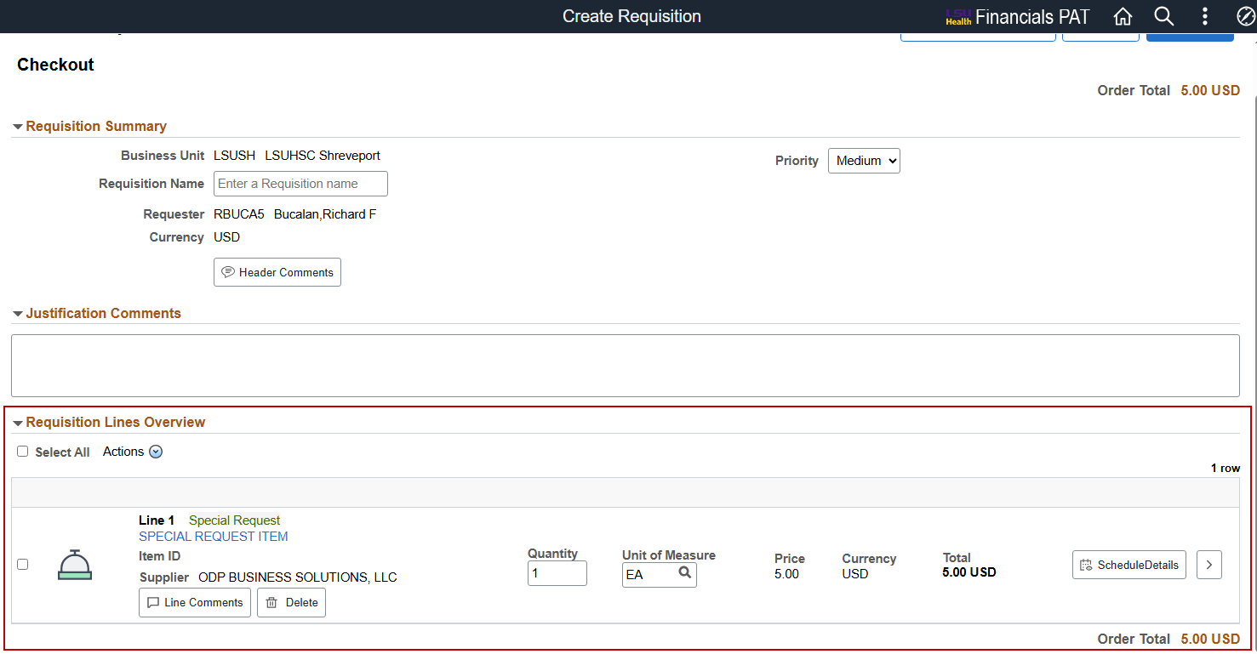
Each item in the cart is shown as a line item in the requisition. Final adjustments to quantity and unit of measure (only if the item is a special request) can be made.
Line comments can be added by selecting the Line Comments button.
To update more details of the item and to update the shipping and chartfield information, click on the ScheduleDetails button at the end of the line.

Requisition Line Details page – Schedule Details tab
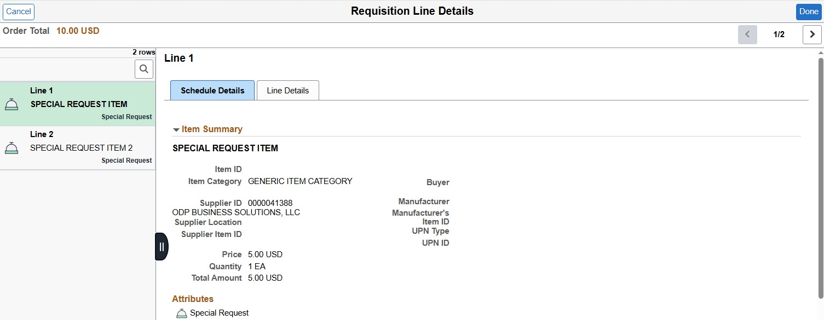
In the Requisition Line Details page, a tab for Schedule Details and one for Line Details are available for each item in the requisition. Navigating between items can be done using the left-hand menu.
The Schedule Details tab displays an item summary and shipping information. The Ship To location, item quantity, and Due Date can be updated in this section. Ship To Comments can also be added.

Requisition Line Details page – Distributions Section
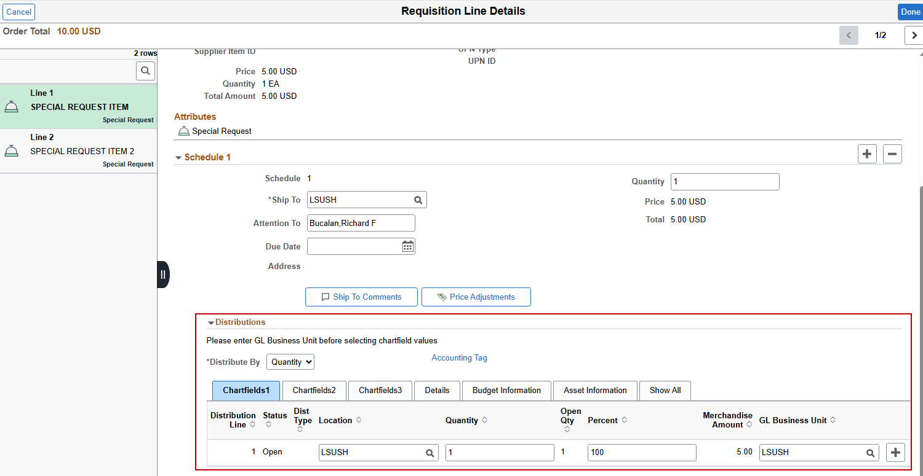
Chartfield and budget information can be updated in the Distributions section across several tabs. Below are the noteworthy fields and the tabs where they can be found:
- Chartfields 1 – Location, Quantity, Percent, GL Business Unit
- Chartfields 2 – Account, Fund, Department, Program code, Class
- Chartfields 3 – PC Business Unit, Project, Activity
- Budget Information – Budget status, Pre-encumbrance balance
The Distribution method for this line item can be set to Quantity or Amount using the dropdown menu just above Chartfields 1 tab.
Chartfields can also be entered by using the Accounting Tag link just above the Details and Budget Information tabs.

Using Accounting Tags in the Distribution section
In the Distribution section of the Requisition Line Details – Schedule page and in the Requisition Defaults page, Accounting Tags can be used to efficiently enter chartfield information.
Accounting Tag found in the Requisition Defaults page
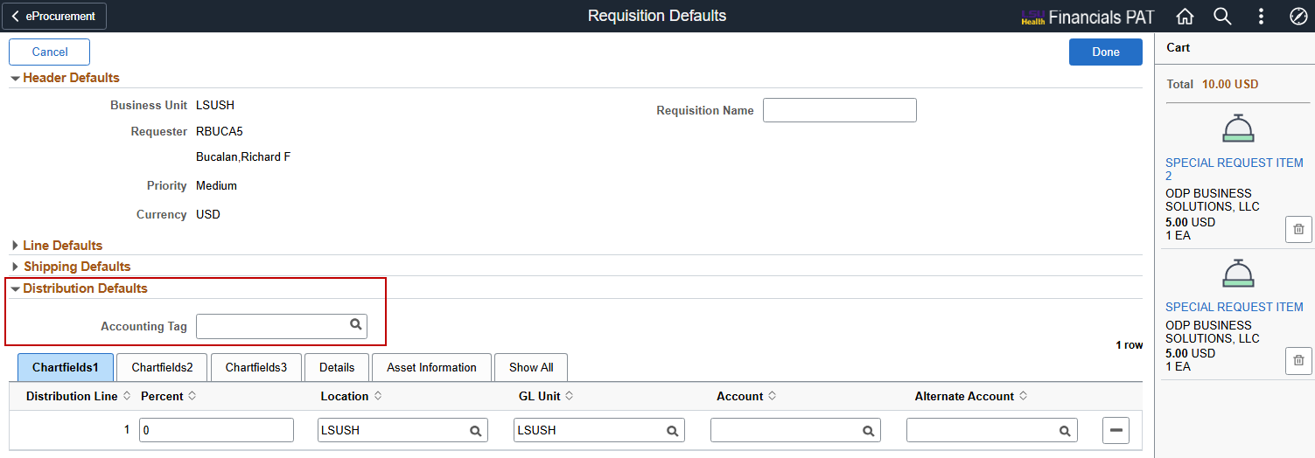
Accounting Tag found in the Requisition Line Details – Schedule page
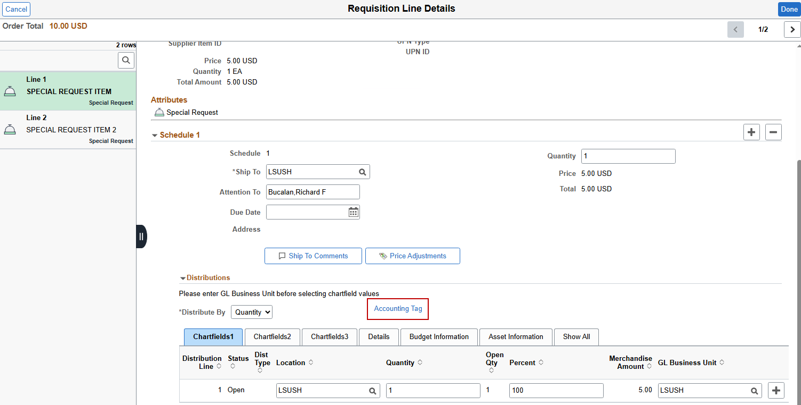

Add a Favorite Accounting Tag
After opening the Accounting Tag link, a new pop-up page will appear with two interactable elements – Manage Favorites and Add button under the Accounting Tag List section.
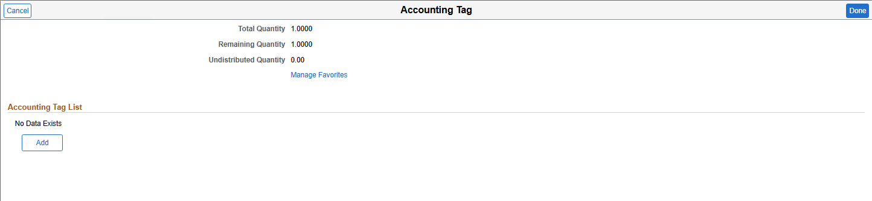
Select the Manage Favorites link to find and add favorite accounting tags
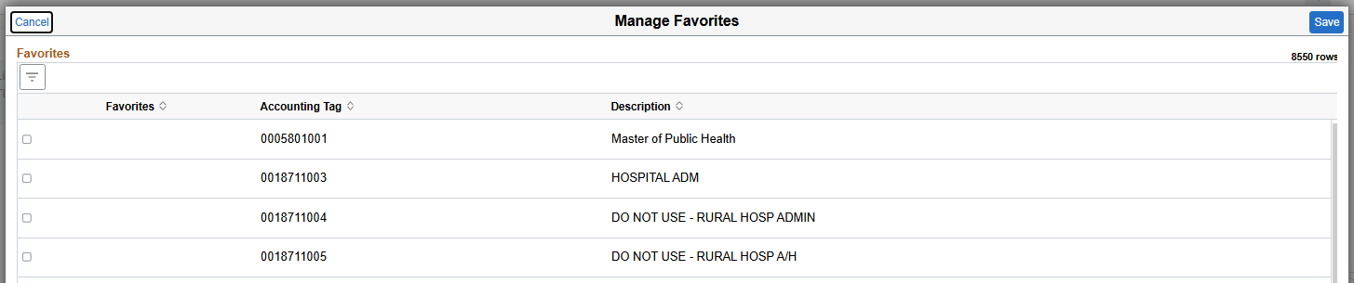
In order to find an accounting tag, the Filter icon must be clicked to open a new window
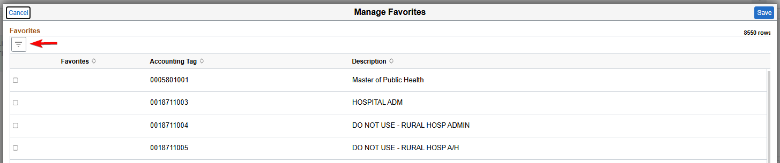
After an accounting tag has been entered, the magnifying glass next to it can be clicked and the specific accounting tag selected in the next window. In this example, 5497601001 was entered as the Accounting Tag
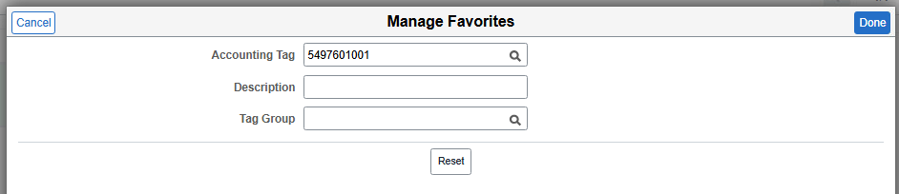
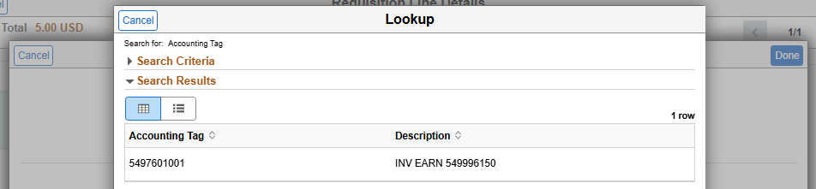
Selecting the Done button will add the accounting tag as a favorite. Select the checkbox for the Accounting Tag and then Save. The accounting tag will not save as a Favorite if the checkbox isn’t checked.
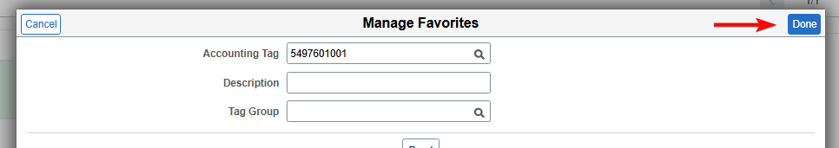
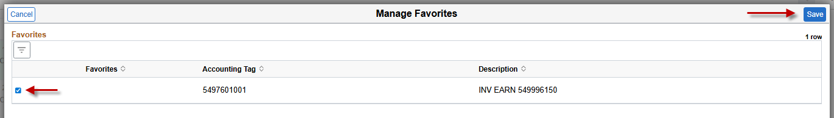
Adding an Accounting Tag as a Favorite does not select it for use in the requisition just yet.

Use a Favorite Accounting Tag for a Requisition
To add an Accounting Tag for the requisition, click the Add button and then the Filter Items button on the next screen
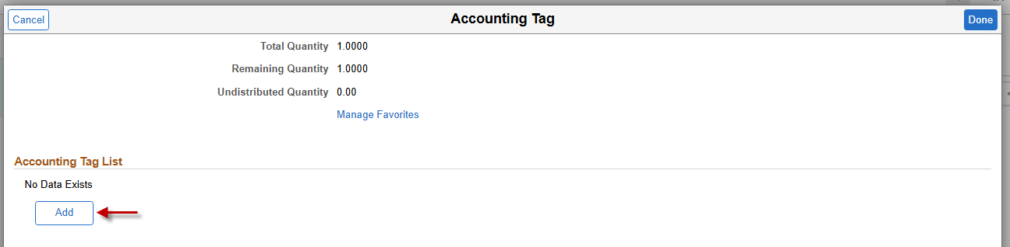
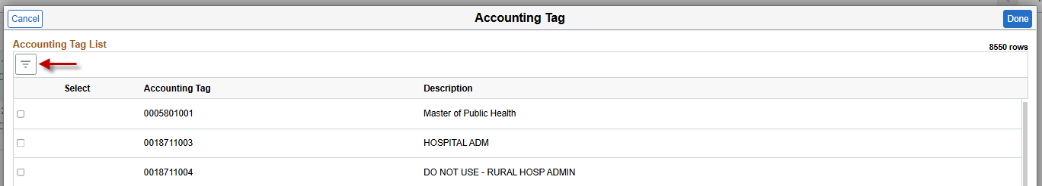
An Accounting Tag can be searched individually, or a favorite Accounting Tag can be selected by choosing the “Favorite” option from the List dropdown menu
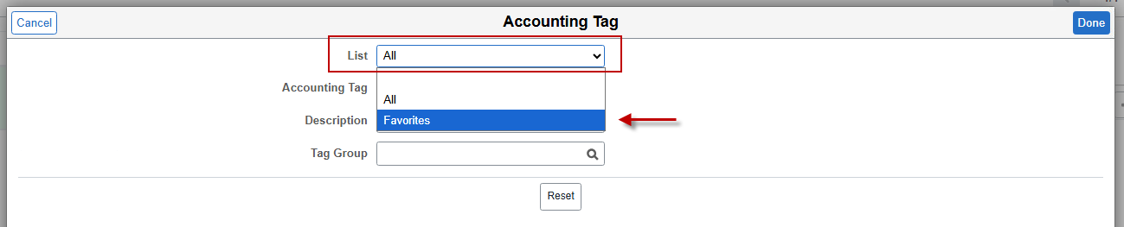
After selecting “Favorites”, click the Done button and a list of favorite Accounting Tags will display. Select one and then click Done. Then, select the checkbox for the accounting tag and select Done
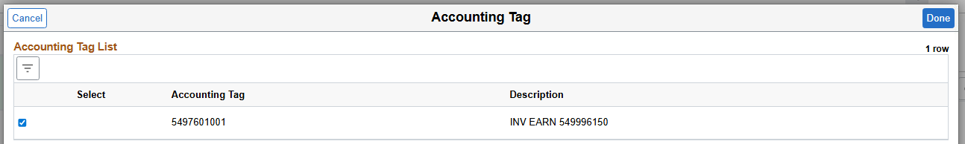
The next screen allocates the percentage or quantity of the line to be allocated to the accounting tag. For single-distribution accounting tags, allocate the entire quantity or 100%.
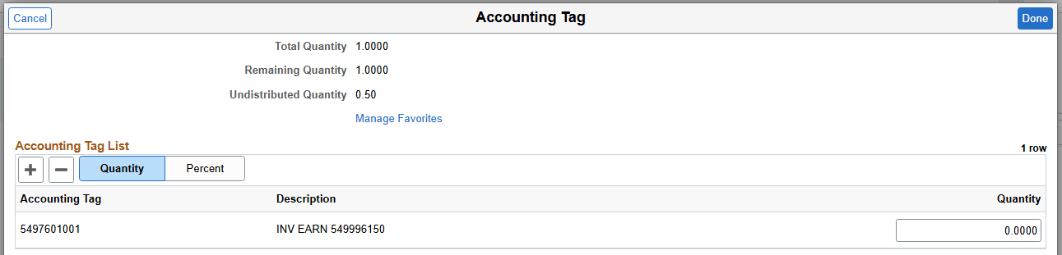

Use a Non-favorite Accounting Tag for a Requisition
If a non-favorite accounting tag is used, set List to All. If the exact accounting tag is known, enter it in the Accounting Tag text box. Then select Done.
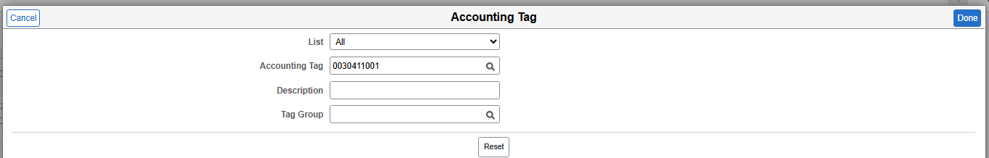
If the exact accounting tag is not known, select the magnifying glass in the accounting tag text box. A new lookup window will appear.
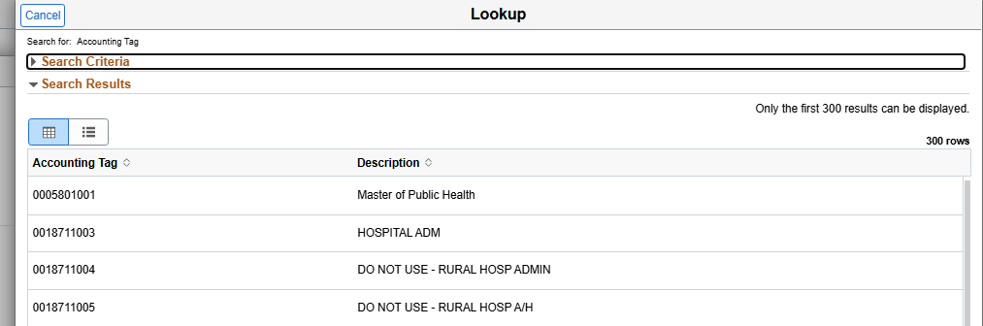
Expand the Search Criteria section in order to search by initial accounting tag digits or description and click Search. In this example, the text “electronic” was used to search for an accounting tag.
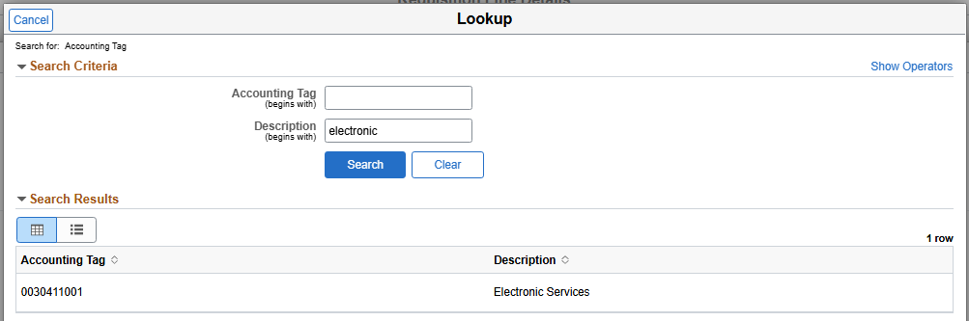
The next screen allocates the percentage or quantity of the line to be allocated to the accounting tag. For single-distribution accounting tags, allocate the entire quantity or 100%.
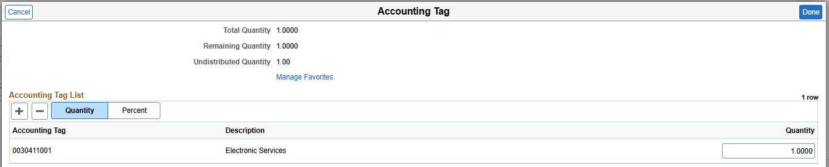
After applying an accounting tag to the requisition line, the relevant fields in Chartfields 2 and Chartfields 3 tabs will update.

Requisition Line Actions
Above the first requisition line, a menu for Actions is available, where an action can be performed on one or many requisition lines.
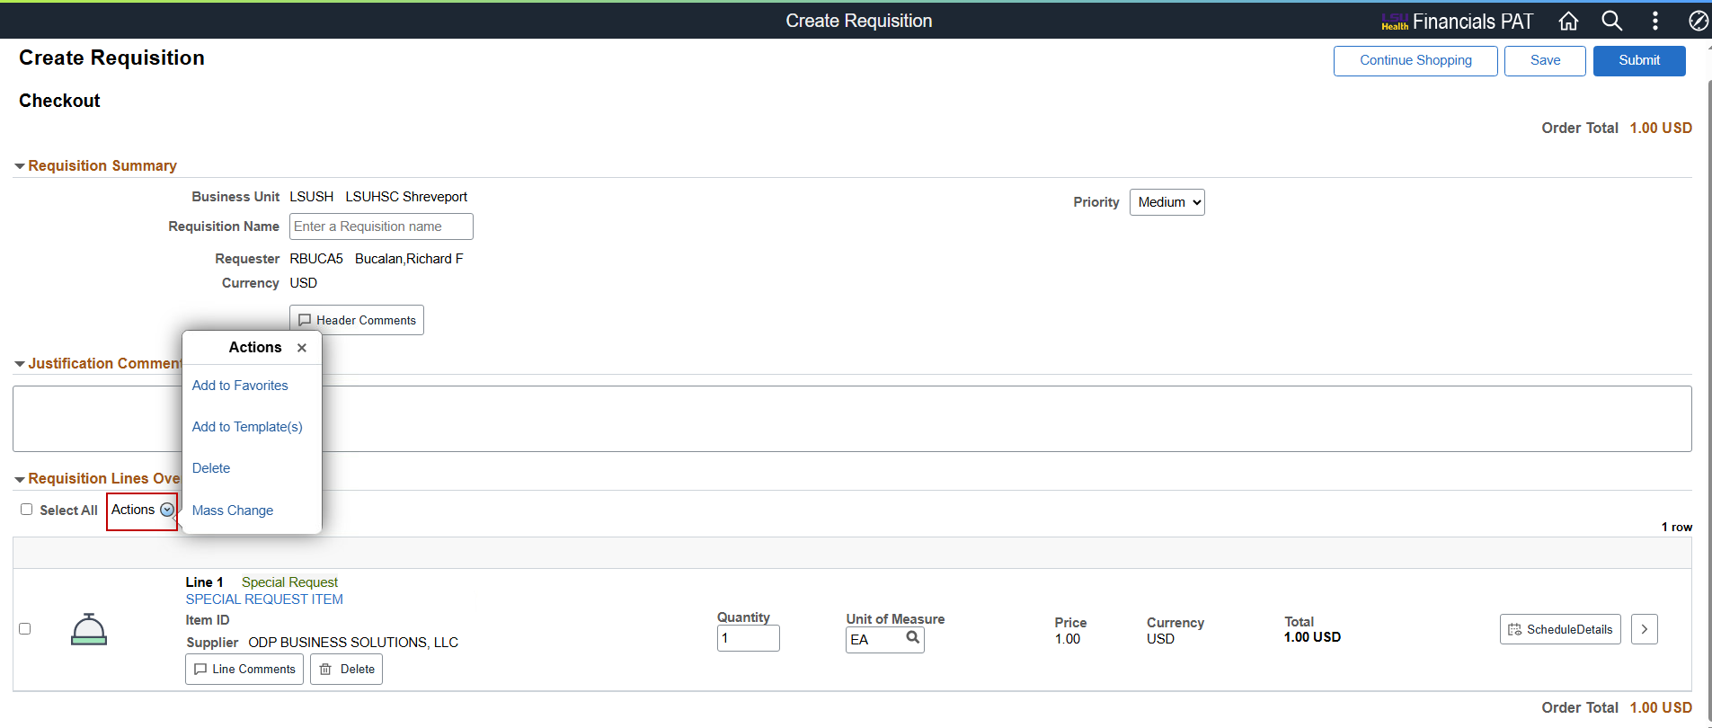
To execute an action on all requisition lines, select the checkbox next to Select All
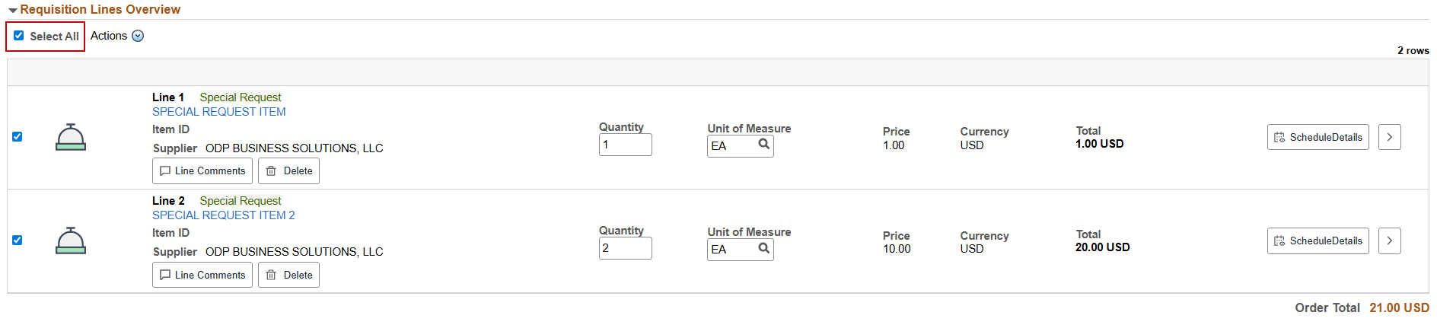
To select specific line(s), select the checkbox next to the desired requisition line
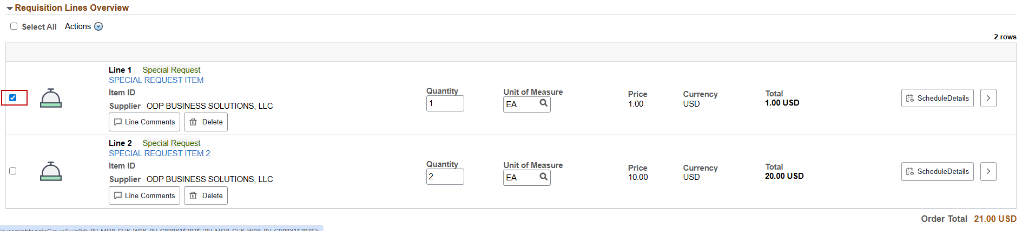

Add to Favorites
Requisition line items can be added as a Favorite for quick access to reordering. Special Requests and Punchout items can be added as favorites.
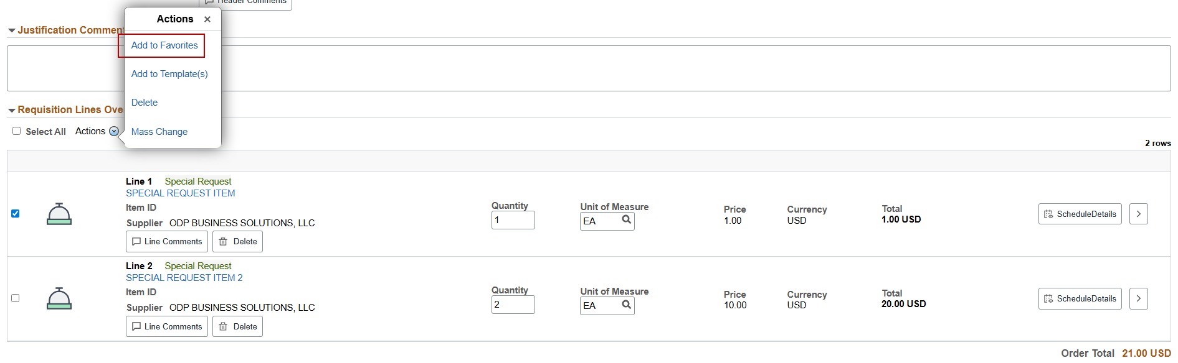
In this example, requisition line 1 and the action Add to Favorites was selected. A message will display to confirm this action.
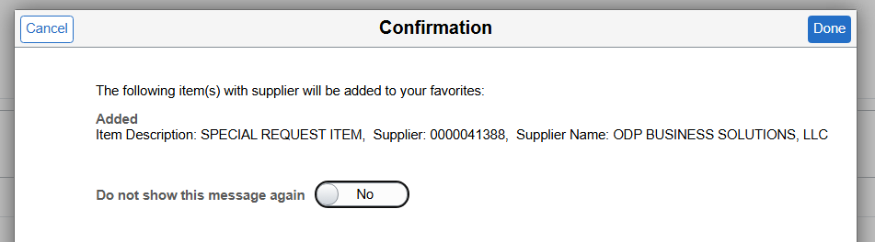
The item is available in the Favorites page on the eProcurement Main page
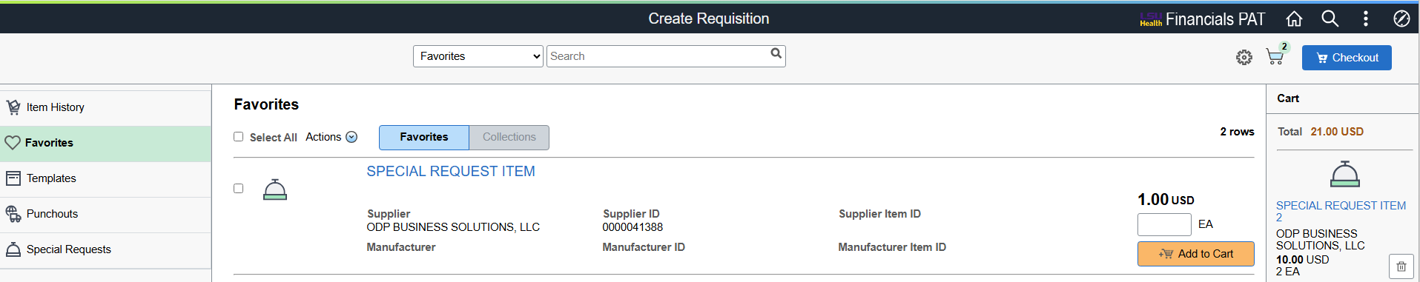

Add to Template(s)
Requisition Templates can be created for reordering entire requisitions or multiple recurring requisition line items
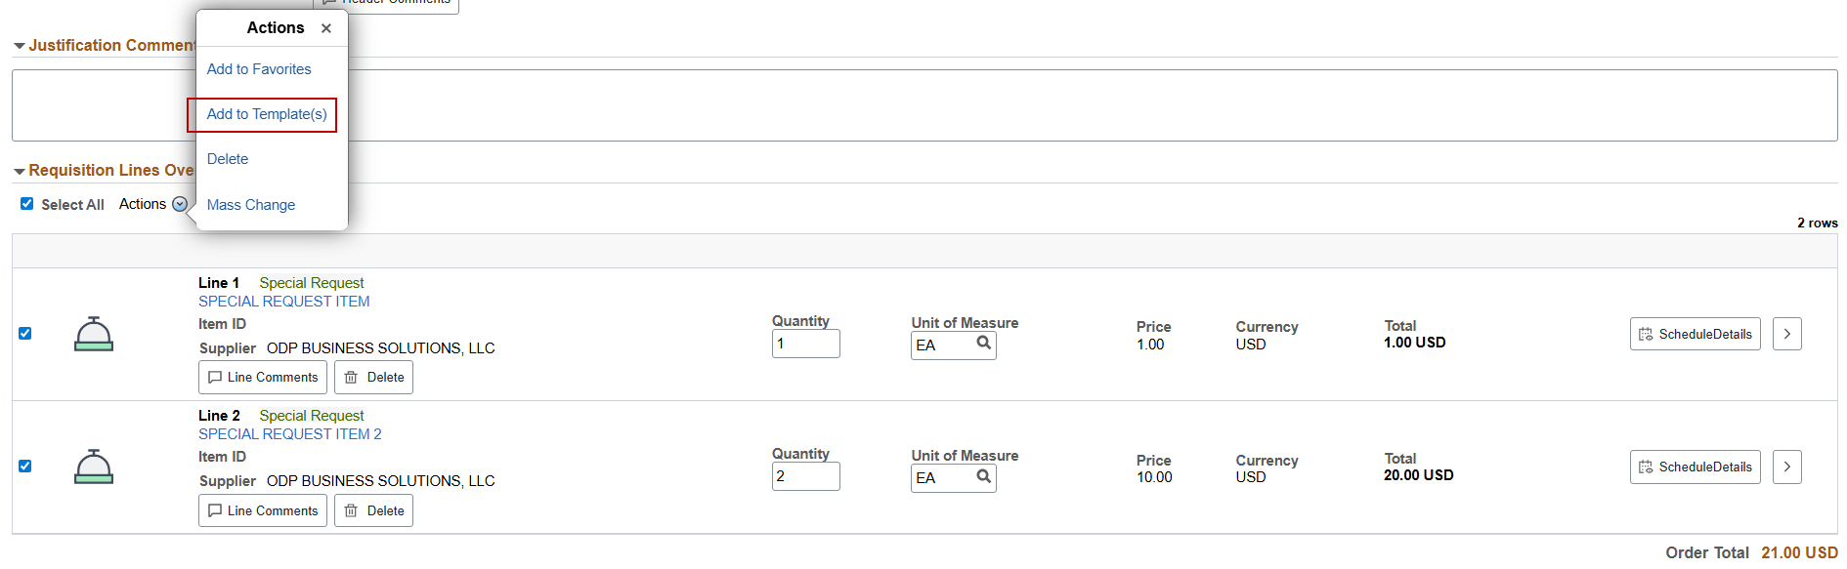
In this example, lines 1 & 2 and the action Add to Template(s) was selected. A new window will display for adding a new template or adding these lines to an existing template.
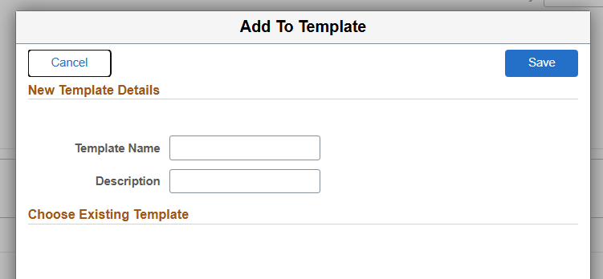
For a new template, enter a template name and description and then Save
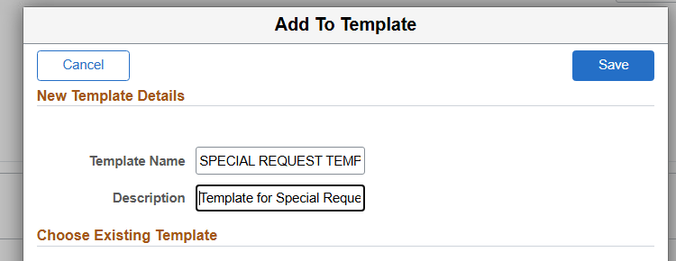
The template is now available in the Templates - Personal page on the eProcurement Main Page
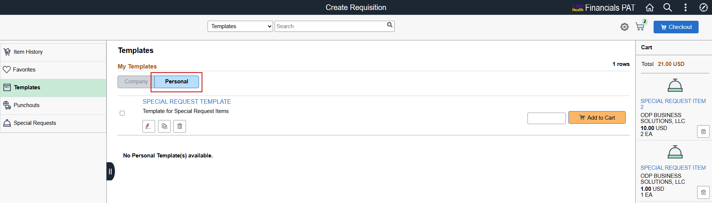
New items can also be added to existing templates. In this example, line 3 is added to SPECIAL REQUEST ITEM TEMPLATE
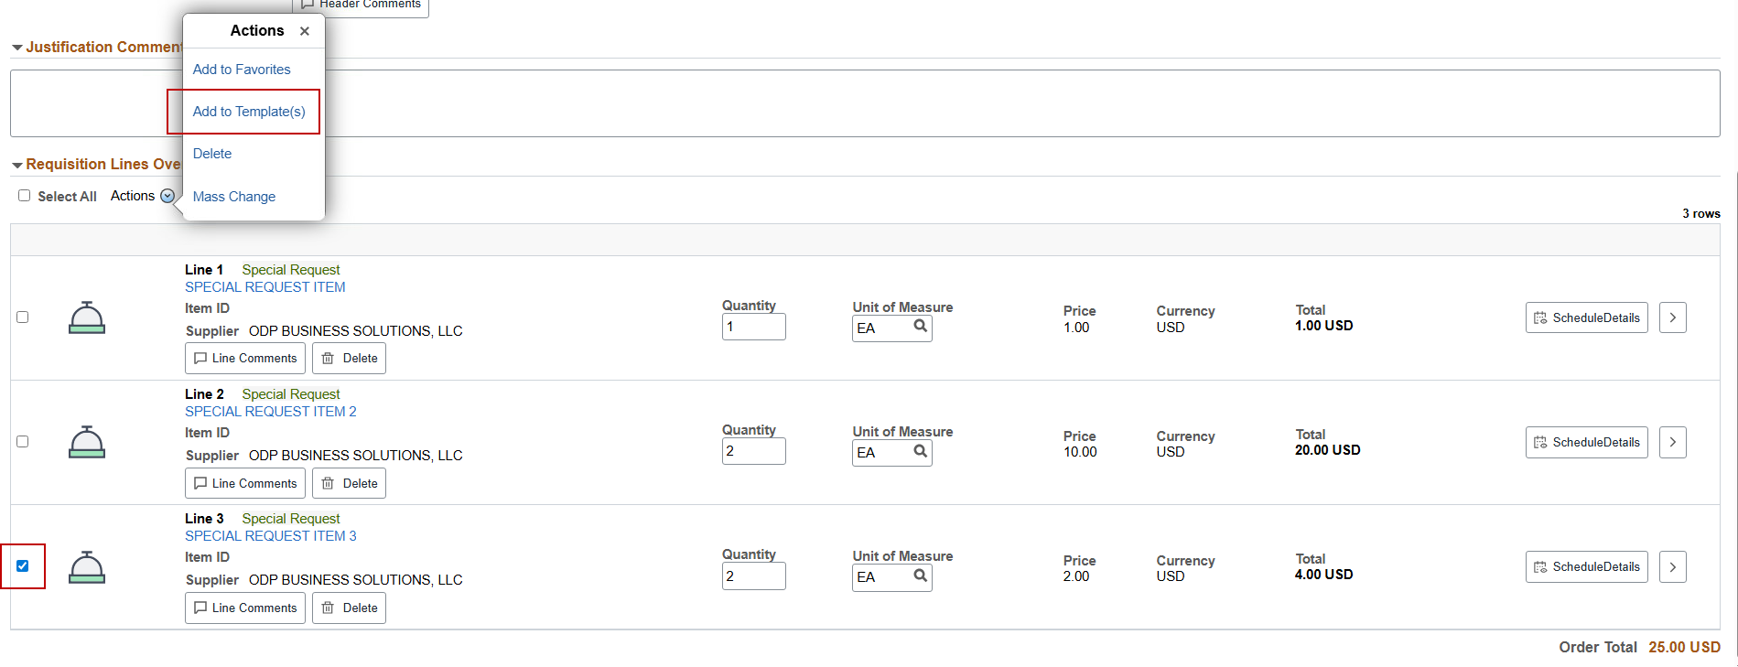
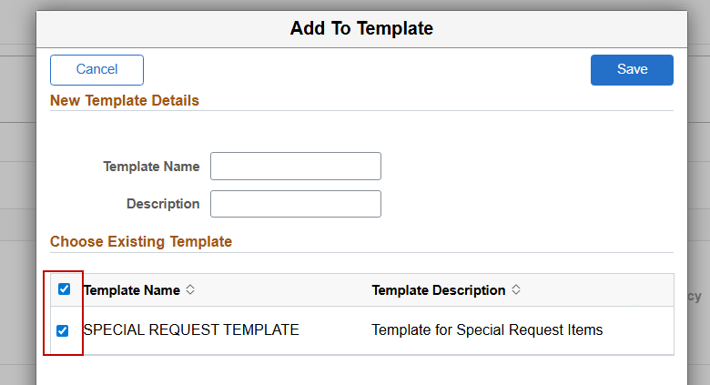

Delete
One or more selected lines can be removed with the Delete action. In this example, requisition line 3 is deleted
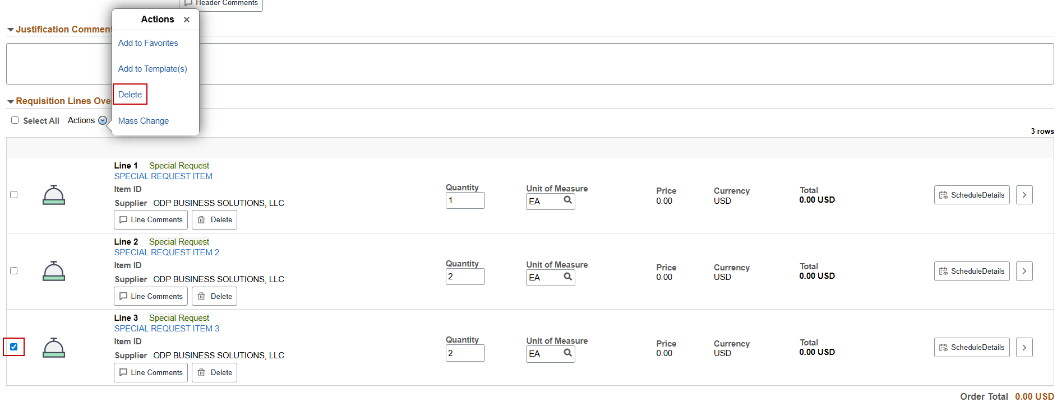
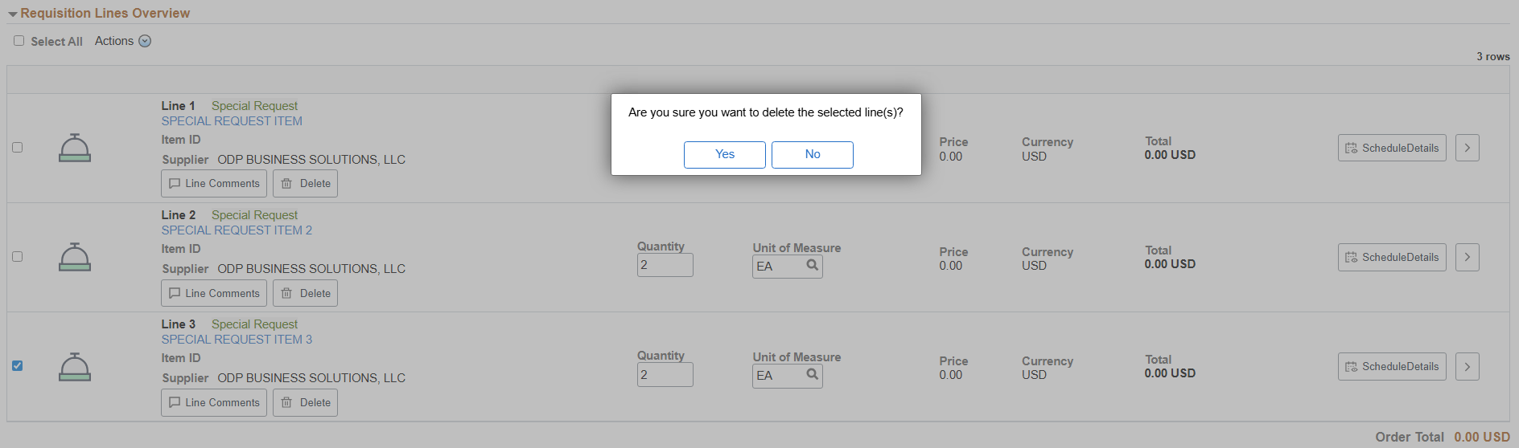
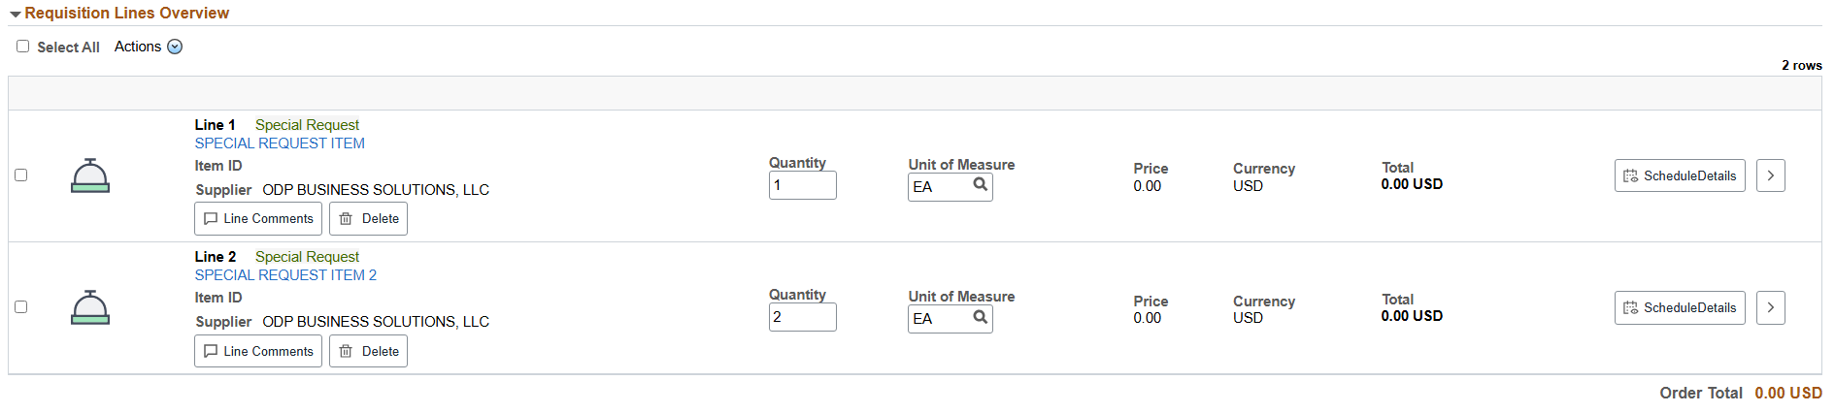

How to update Requisition Lines using Mass Change action
Requisition lines can be updated on an individual line basis using all the pages and features explained above. However, to make changes to multiple requisition lines and their distributions (i.e. account, department, fund, program, class, and project ID) at one time, the Mass Change action is recommended.
In the old version of eProcurement and in the older version of requisitions before that, changes to Requisition Line Distributions were often made in the Requisition Defaults page. That is not possible anymore with fluid eProcurement. Changes to entire requisitions must be made with the Mass Change action or done on requisition lines individually.
Select one or more requisition lines, and then select the Mass Change action
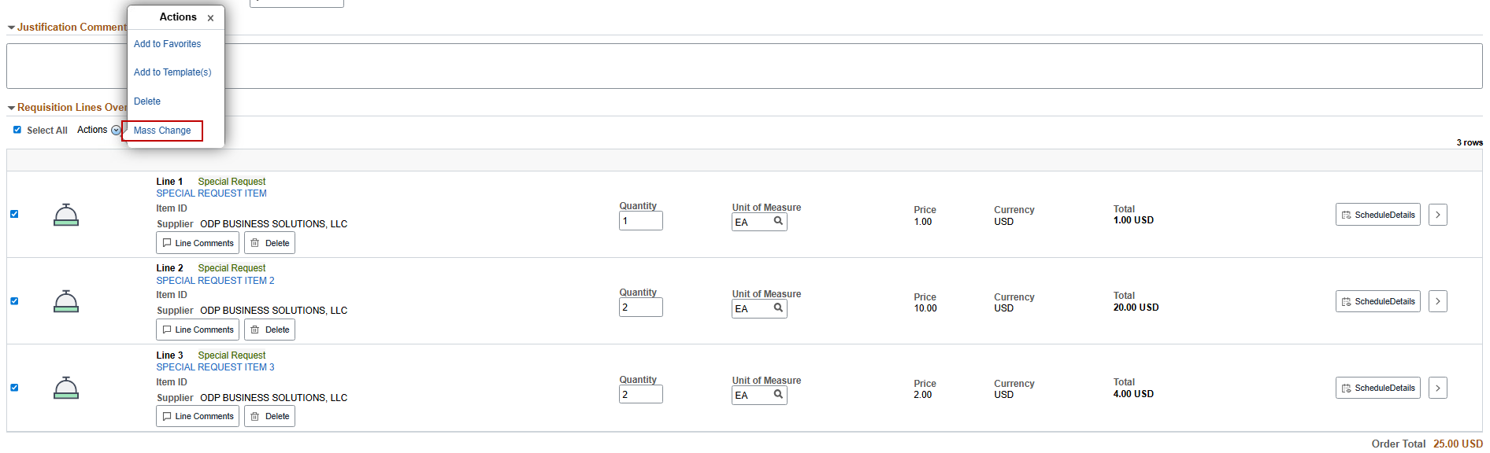
The Mass Change window will display
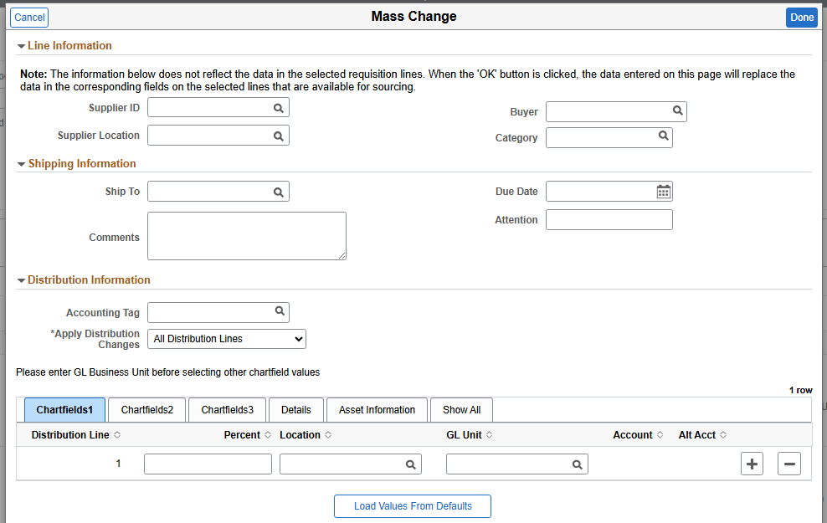
Under Line Information and Shipping Information, specific frequently-updated fields can be changed, such as Supplier ID, Buyer, Ship To, and Due Date

Updating Requisition Line Distributions
In the old versions of eProcurement and Add/Update Requisitions, the common practice for updating account, department, fund, program, class, and project ID was done in Requisition Defaults. This practice is not valid anymore. It must be done using Mass Change.
In the Distribution Information section, fields from the requisition line distribution can be updated.
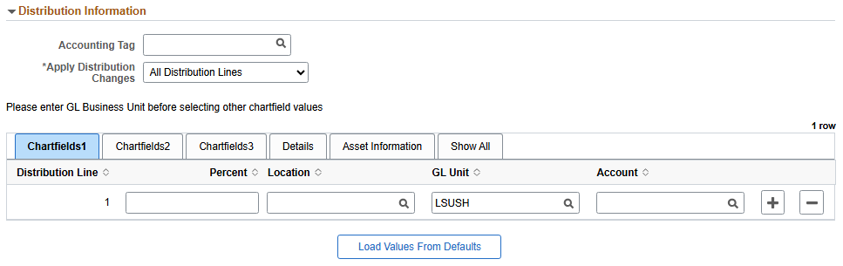
Below is a list of the primary chartfields for updating
- First, enter LSUSH in the Chartfields1 - GL Unit chartfield
- Chartifleds1 tab: Account
- Chartfields2 tab: Fund code, Dept, Program, Class
- Chartfields3 tab: PC Business Unit, Project, Activity
These fields can be entered manually, or an Accounting Tag can be used.

Using an Accounting Tag in Mass Change
An Accounting Tag can be used to update requisition line distributions in Mass Change.
**Warning** The values of the Accounting Tag will replace whatever is on the requisition line distribution. If the selected Accounting Tag has only 1 distribution but your existing requisition line distribution has 2 lines, then the 2 distributions will be replaced by the 1 distribution found in the accounting tag.
Only an accounting tag with multiple distributions can update requisition lines with multiple distributions. In general, it is not recommended to use an accounting tag if updating requisition lines with multiple distributions.
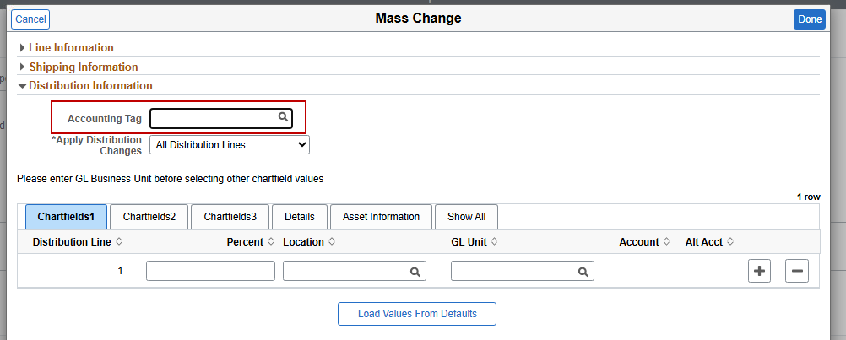
Manually enter a specific Accounting Tag or select the magnifying glass to search for one.
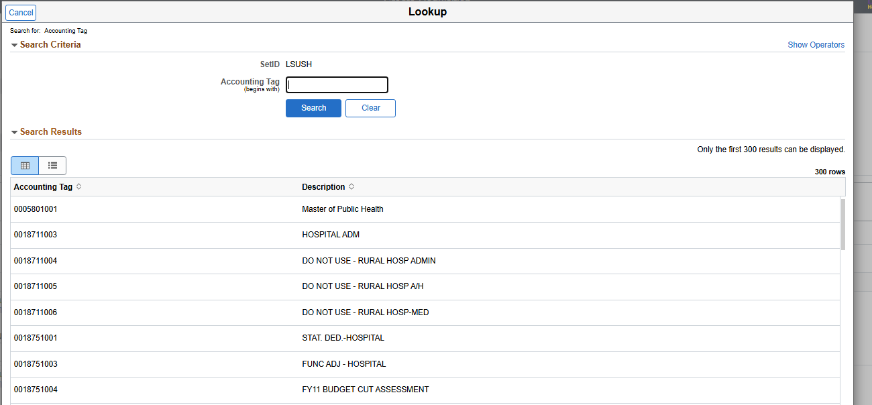 In the search page, enter the initial digits of the Accounting Tag if the full accounting tag isn’t known and then select Search.
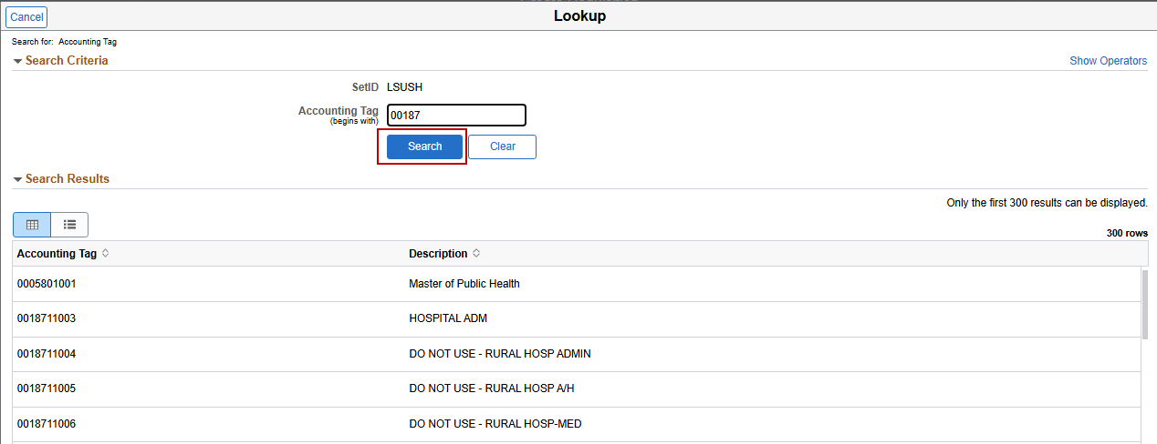
The search results display all accounting tags that start with the initial digits entered
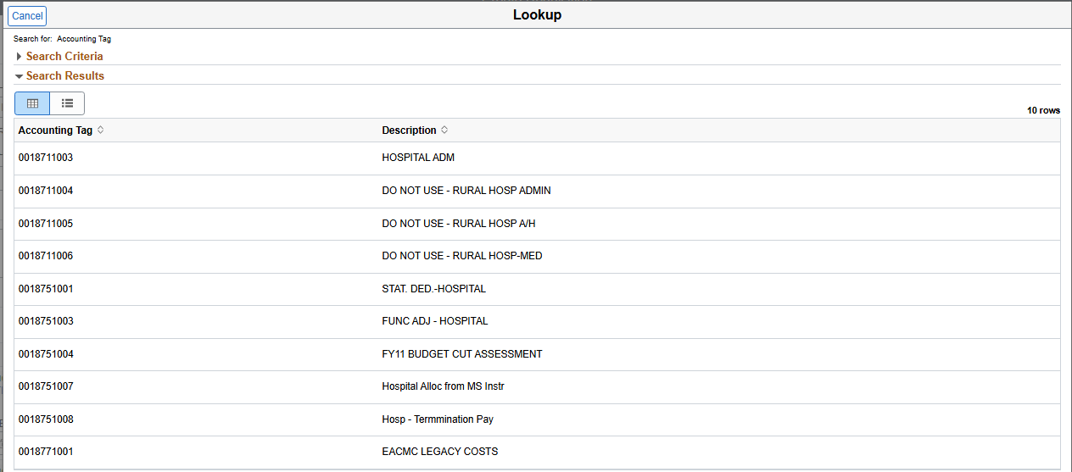

Apply Distribution Changes Options
After entering updated chartfields values, select which type of distribution change is required in the Apply Distribution Changes menu.
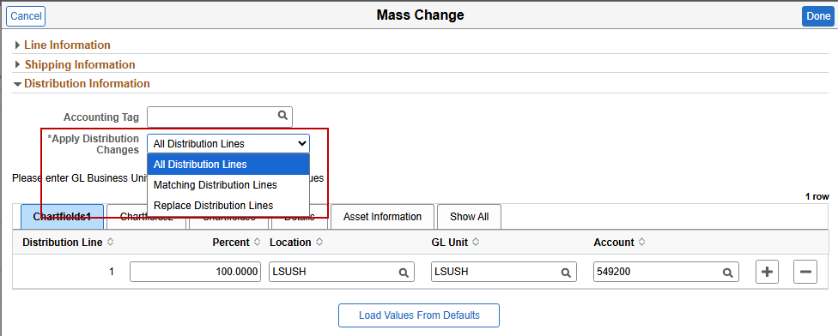
There are certain key distinctions between each option.
- All Distribution Lines – use this option if only 1 distribution should be applied to all line distributions. This includes if a requisition line contains multiple distributions. In this option, only the chartfields that were updated will be changed in the existing distributions.
  - For example, if only the department is changed, only the department on the requisition line distributions will be changed. All other existing values in the requisition line distributions will remain the same.
- Matching Distribution Lines – use this option if you want to update existing line distributions with a new one and delete unwanted lines
  - If a req line distribution contains 2 lines and the mass change updates only 1 line, “req line 1 / distribution 1” will be updated and “req line 1 / distribution 2” will be deleted
  - Not recommended to use
- Replace Distribution Lines – use this option if a new distribution split must be applied to existing lines. This is the default choice when using an accounting tag
  - Existing distributions will be completely replaced, regardless of the number of distribution lines for the line item
  - If requisition line 1 has only one distribution line and the mass change contains two distribution lines, requisition line 1’s distribution will then have two distribution lines after mass change
  - If only one chartfield was entered (i.e. department) and all other chartfields were left blank, then the requisition line distribution will be changed to have only the department chartfield value and all others will be empty.

Save the Requisition without Submitting
To save the requisition without submitting, select the Save button in the Checkout page
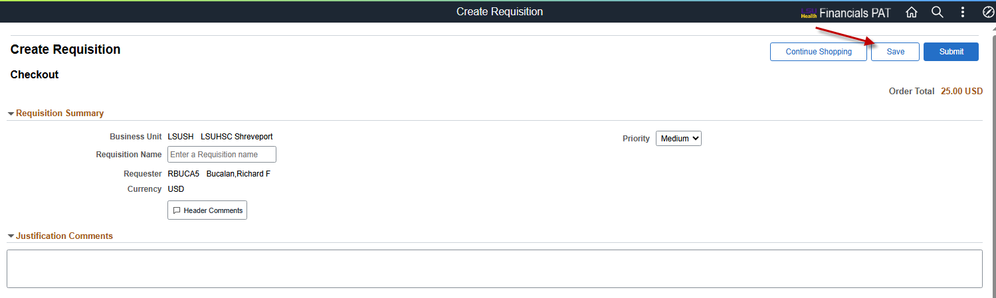
This will save the requisition and create a requisition ID number. The Edit Shopping Cart page will display, and the requisition name, quantities, and units of measure can be edited. To continue, select the Checkout button.
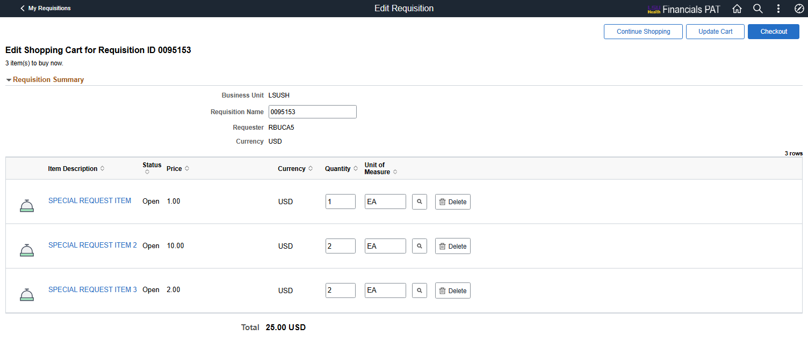
If checkout is not selected at this time, the requisition can be access again using the My Requisitions tile within eProcurement. **See Managing Requisitions section for further explanation**

Submit Requisition and Checkout Confirmation
To complete the requisition and submit for approval, select the Submit button
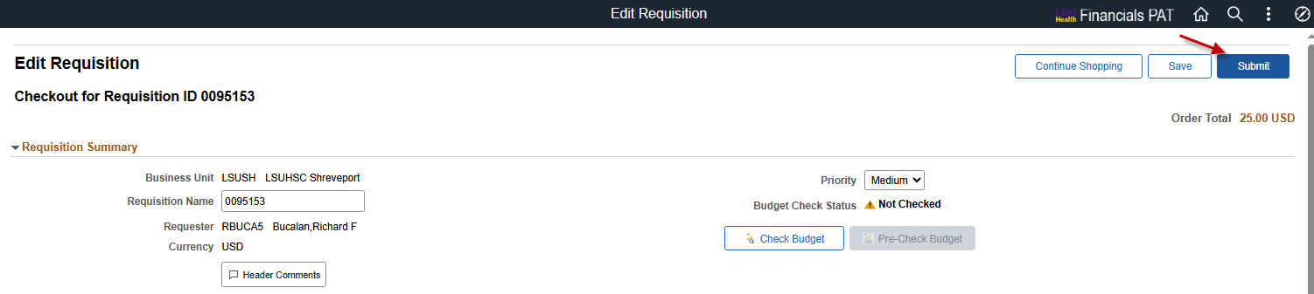
The Checkout Confirmation page will display.
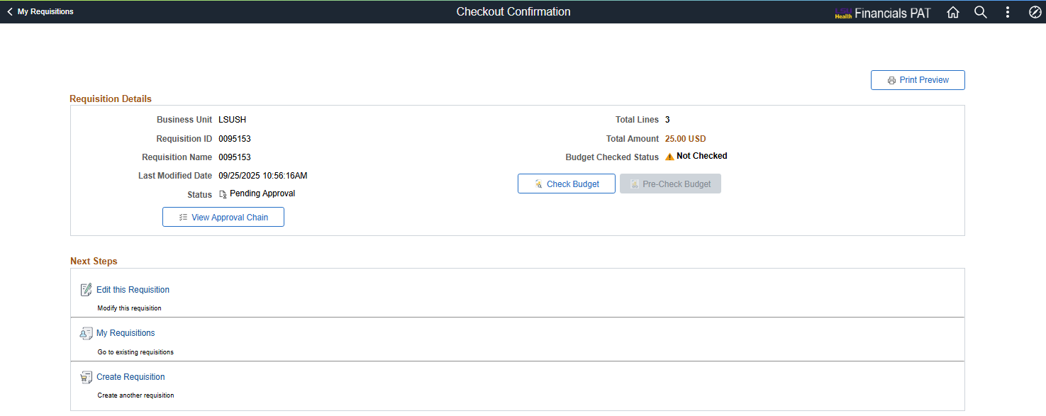
Select the View Approval Chain button to view who can approve the requisition. This will open a separate window
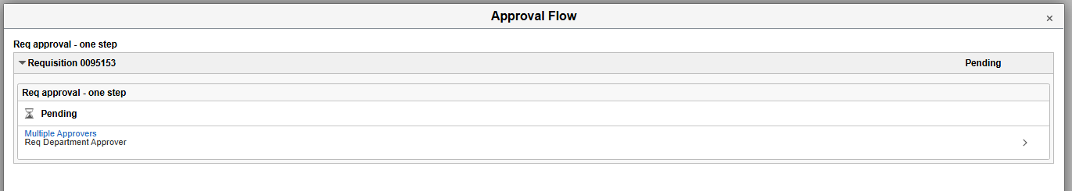
Select the Multiple Approvers link to view the list of approvers.
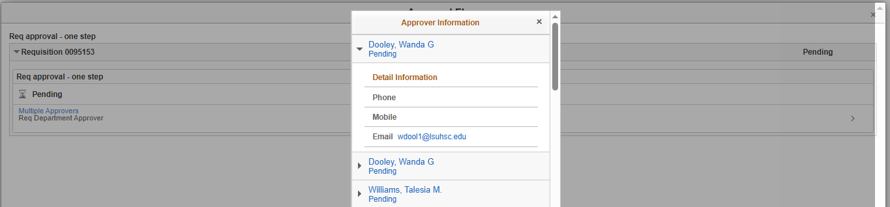
Other actions available in this page:
- Check Budget to perform a budget check on the requisition. However, this cannot be done until the requisition has been approved.
- Select Print Preview to view a PDF version of the entire requisition that can be printed.
- Edit this Requisition to make changes to the requisition
- My Requisitions navigates to the page where other existing requisitions can be accessed
- Create Requisition navigates to the eProcurement Main Page for creating a new requisition

Managing Requisitions
To manage an existing requisition, select the My Requisitions tile within eProcurement
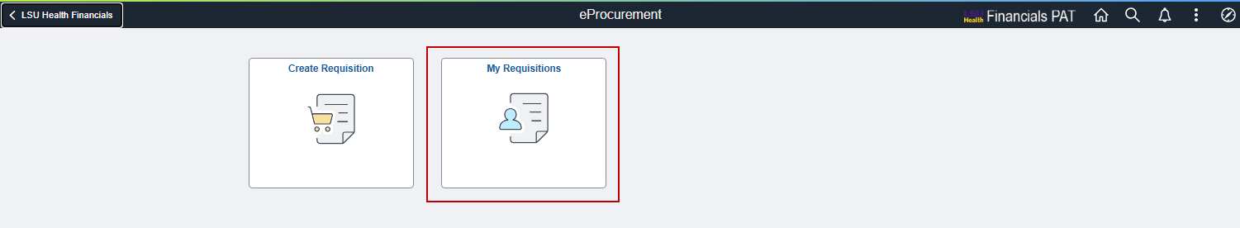
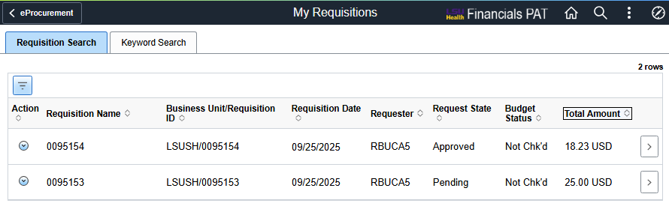
By default, the My Requisitions page will display requisitions created by you on the current date (today). To filter for more or fewer requisitions, select the Filter button at the top-left of the requisition section.
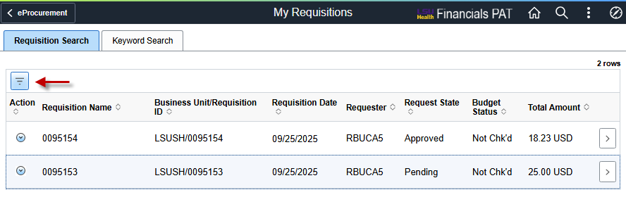
The filter options page will display
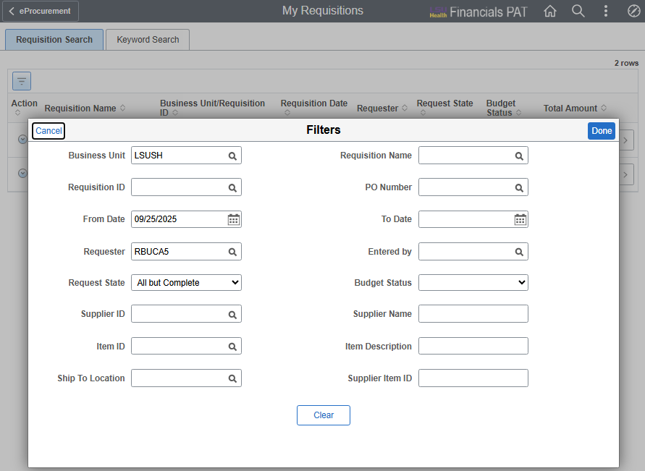
Delete the date in the From Date field to view all your requisitions. Or enter a time span in the From Date and To Date to view requisitions from a specific date range.
If you have access to edit requisitions for other people, delete the value in the Requester field.

Viewing Requisition Details
To view details of the requisition, click anywhere in the general line of the requisitions or select the > button at the end of the line
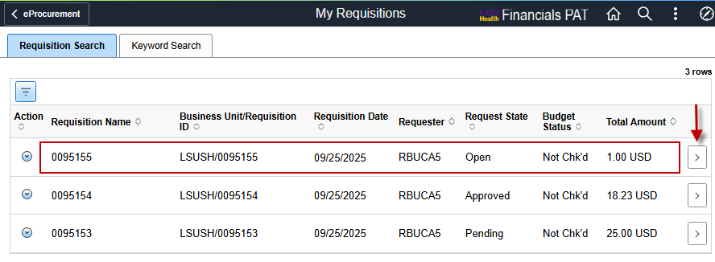
This will display the Details page, where information on the requisition can be viewed.
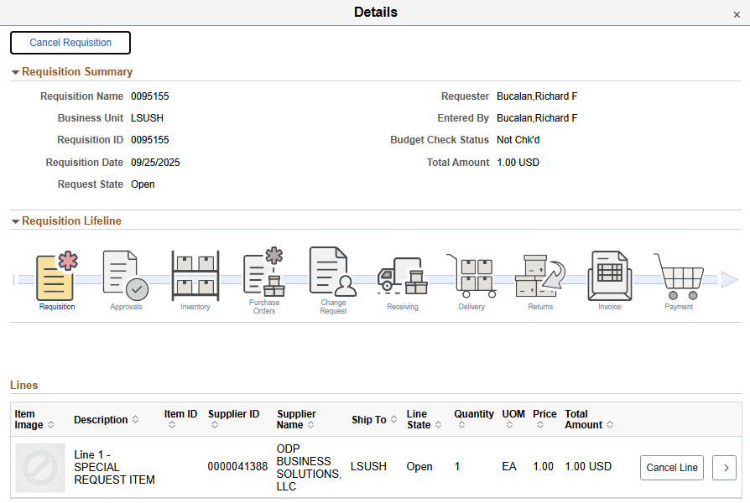
Requisition Summary shows header information.
Requisition Lifeline displays the current status in the procure-to-pay lifecycle by coloring the icon for each stage. For example, the requisition above has been created but not sourced to a purchase order. In the example below, the requisition had been approved, sourced to a PO, invoiced, and paid.
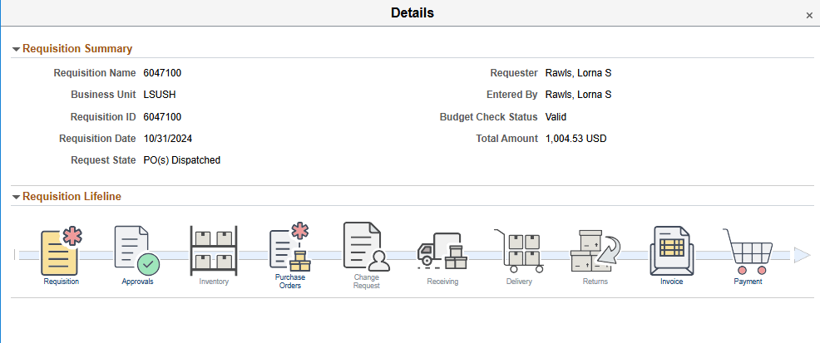
To cancel the entire requisition, select the Cancel Requisition button at the top-left of the page. Or to cancel a specific line, select the Cancel Line button at the end of the line.
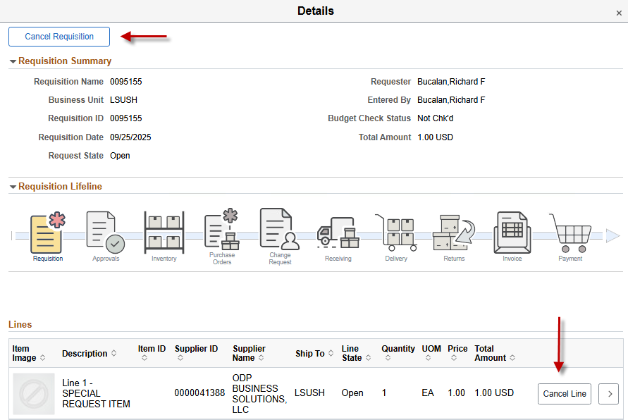
To exit out of this page, click on the tiny X at the very top-right corner
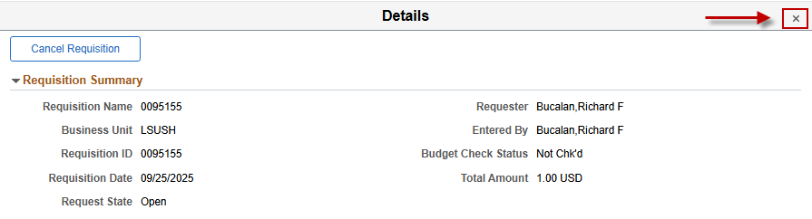

Updating an Existing Requisition
To edit an existing requisition, select the Action Menu button at the very left of the requisition and then select the Edit option.
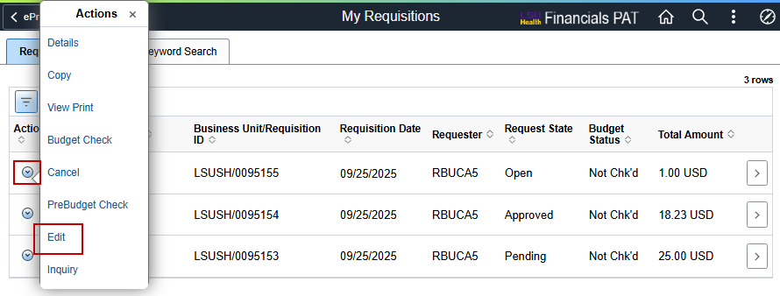
The Edit Shopping Cart page will display, where high-level values can be updated, such as requisition name, item quantity and unit of measure. Select the Checkout button to continue with checking out and submitting the requisition.
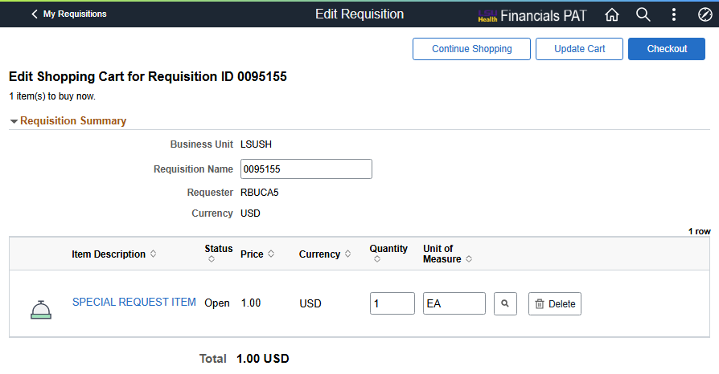
In the Checkout page, more values such as chartfields and item details can be updated before submission.
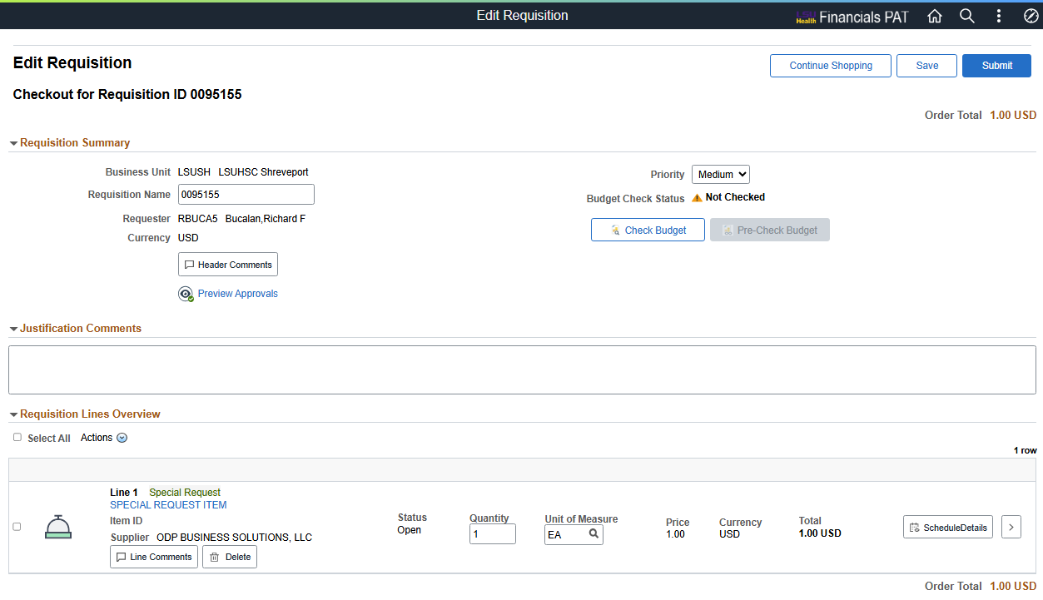

Other Actions in My Requisitions Page
Depending on the request state of the requisition, several more actions are available.
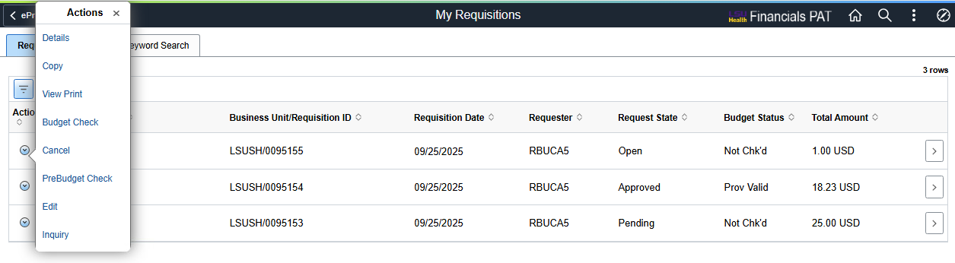

Details
This option is the same as the View Requisition Details explained above.

Copy
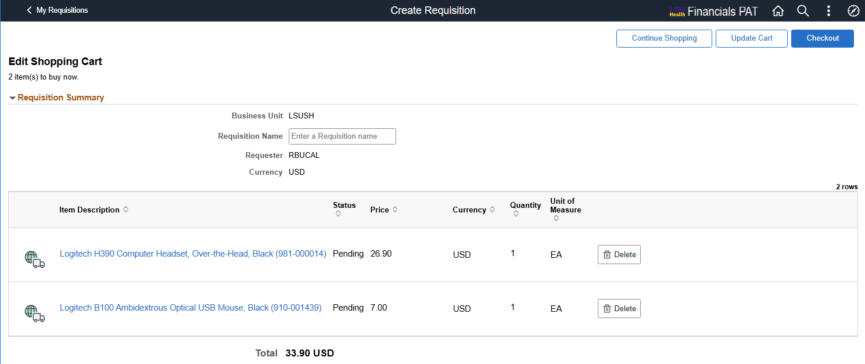
Copying a requisition brings up the Edit Shopping Cart page where items can be removed from the cart. Selecting the Checkout button brings up the Checkout page, where comments and attachments can be added and line details / chartfields can be edited

View Print
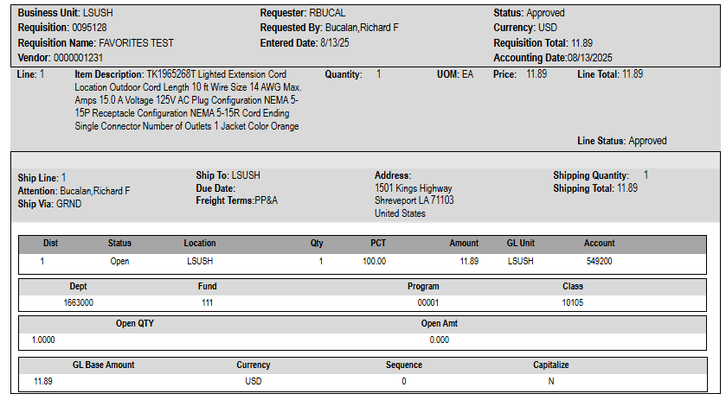
A PDF version of the full requisition is displayed and can be printed.

Budget Check
Select to check the budget of the requisition. Only Approved requisitions can be budget checked.

PreBudget Check
To see if the requisition will pass budget check without committing to do so, select PreBudget Check. If successful, the budget status will update to Prov Valid for provisionally valid
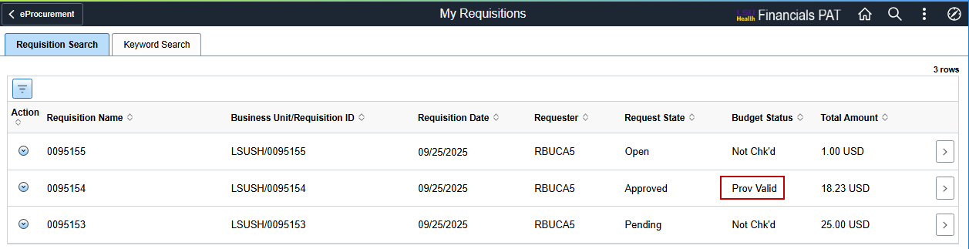

Cancel
Selecting Cancel will cancel the entire requisition. Depending on the filter parameters, the canceled requisition will still display in the My Requisitions page and there will be a new action to undo cancel.
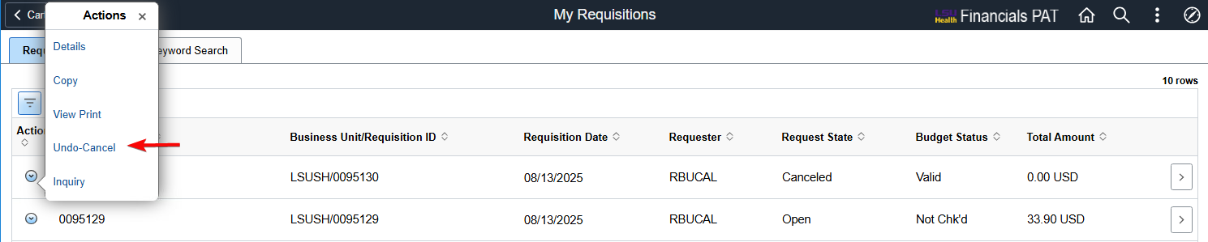

View Approval
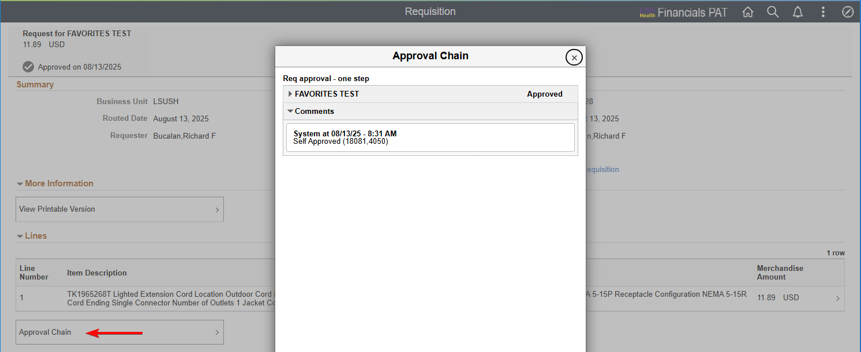
A separate window will display the current approval status of the requisition.

Inquiry
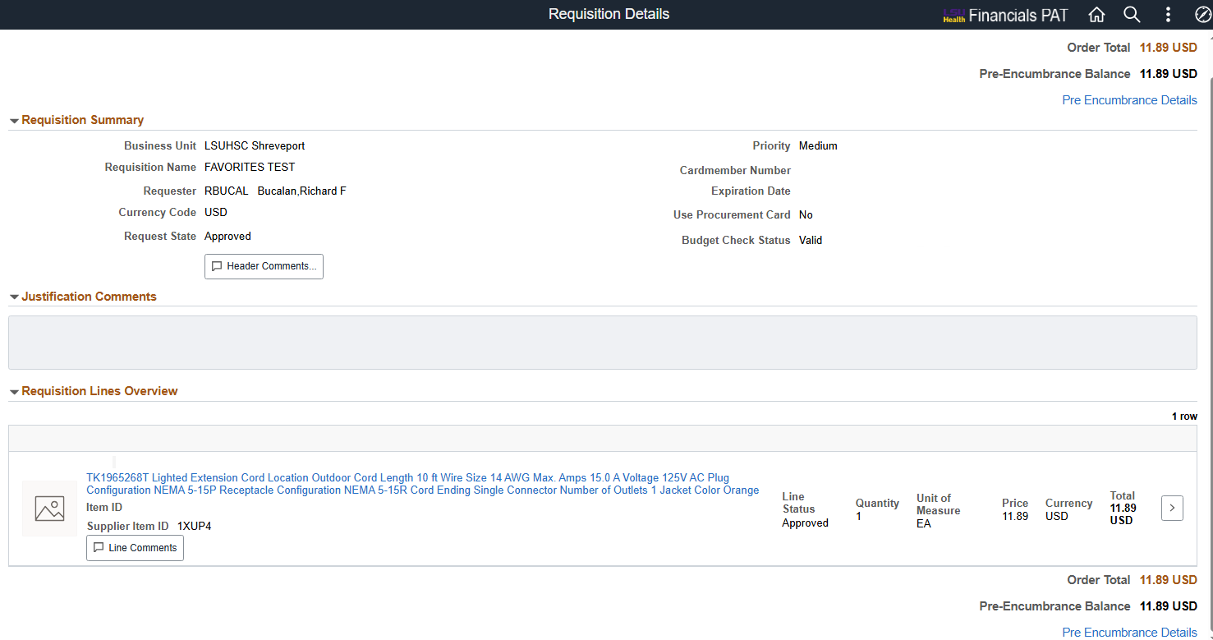
This will display a read-only version of the requisition.

